1. To save time, IOS commands may be partially entered and then completed by typing which key or key combination?

* Tab

1. What command will prevent all unencrypted passwords from displaying in plain text in a configuration file?

* (config)# **service password-encryption**

1. Which two statements are true regarding the user EXEC mode? (Choose two.)

* This is the default mode on an unconfigured router when first powered up.
* Only some aspects of the router configuration can be viewed.

1. Why would a network administrator use the CLI of the Cisco IOS?

* to add a password to a Cisco network device

1. Which device acts as a gateway to allow hosts to send traffic to remote IP networks?

* local router

1. What is encrypted with the **enable secret** command?

* the privileged executive mode password

1. A technician configures a switch with these commands:  
     
   SwitchA(config)# **interface vlan 1**  
   SwitchA(config-if)# **ip address 192.168.1.1 255.255.255.0**  
   SwitchA(config-if)# **no shutdown**

1. What is the technician configuring?

* SVI

1. Which statement describes a feature of an IOS host name configuration?
   * It does not allow spaces
2. Fill in the blank.  
   A  address is defined as a reserved address that routes packets back to the host.

* loop-back

1. An administrator has just changed the IP address of an interface on an IOS device. What else must be done in order to apply those changes to the device?
   * Nothing must be done. Changes to the configuration on an IOS device take effect as soon as the command is typed correctly and the Enter key has been pressed.
2. A network administrator has forgotten the argument of an IOS command. How would the administrator get help from the IOS CLI to complete the command correctly?
   * Type the command and then press the **?** key.
3. Why would a technician enter the command **copy startup-config running-config**?

* to copy an existing configuration into RAM

1. What will a network administrator use to modify a configuration on a Cisco router?

* [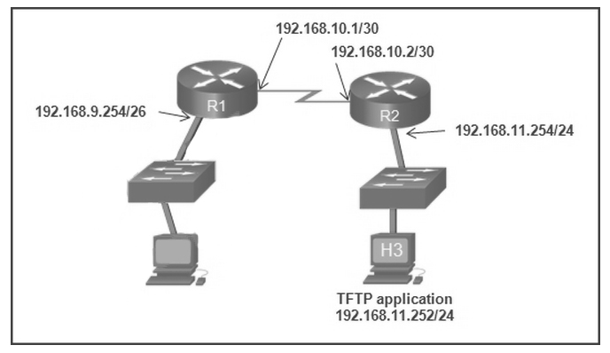](http://ccnav5.com/wp-content/uploads/2013/10/p1.jpg?csspreview=true)IOS

1. **Refer to the exhibit.  
   The network administrator enters these commands into the R1 router:  
   R1# copy running-config tftp**

**Address or name of remote host [ ]?  
When the router prompts for an address or remote host name, what IP address should the administrator enter at the prompt?  
192.168.11.252**

1. **Which three statements characterize the transport layer protocols? (Choose three.)  
   TCP and UDP port numbers are used by application layer protocols.  
   TCP uses windowing and sequencing to provide reliable transfer of data.  
   TCP is a connection-oriented protocol. UDP is a connectionless protocol.**
2. **What is the purpose of ICMP messages?  
   to provide feedback of IP packet transmissions**
3. **A technician uses the ping 127.0.0.1 command. What is the technician testing?  
   the TCP/IP stack on a network host**
4. **What will a Layer 2 switch do when the destination MAC address of a received frame is not in the MAC table?**  
   **It forwards (najprv) the frame out of all ports except for the port at which the frame (rámec) was received (prijatý).**
5. **What is a characteristic of the LLC sublayer?  
   It places information in the frame that allows multiple Layer 3 protocols to use the same network interface and media.**
6. **On which switch interface would an administrator configure an IP address so that the switch can be managed remotely?  
   VLAN 1**
7. **A network engineer is measuring (merať) the transfer of bits across the company backbone for a mission critical database application. The engineer notices that the network throughput (priepustnosť) appears lower than the bandwidth (šírka pásma) expected. Which three factors could influence the differences in throughput? (Choose three.)  
   the amount of traffic that is currently crossing the network**  
   **the type of traffic that is crossing the network**  
   **the latency that is created by the number of network devices that the data is crossing**
8. **When applied to a router, which command would help mitigate brute-force password attacks against the router?  
   login block-for 60 attempts 5 within 60**
9. **Which two statements correctly describe a router memory type and its contents? (Chose two.)  
   ROM is nonvolatile (neprchavý) and contains basic diagnostic software.**  
   **RAM is volatile and stores (ukladá) the IP routing table.**
10. **Which two components are necessary (nutný) for a wireless client to be installed on a WLAN? (Choose two.)  
    wireless NIC**  
    **wireless client software**

12 Launch PT – Hide and Save PT  
[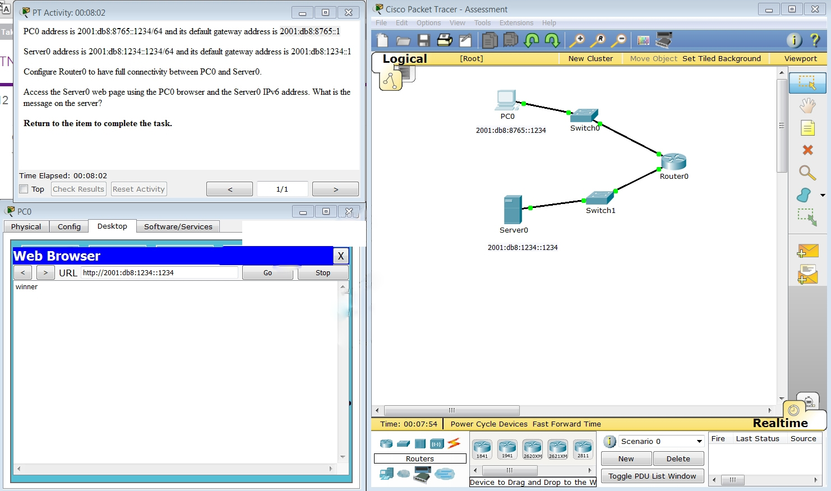](http://ccnav5.com/wp-content/uploads/2013/10/p1211.jpg?csspreview=true)  
Open the PT activity. Perform the tasks in the activity instructions and then fill in the blank.  
The Server0 message is **winner**

1. **A host is accessing a Web server on a remote network. Which three functions are performed by intermediary network devices during this conversation? (Choose three.)  
   applying security settings to control the flow of data**  
   **notifying other devices when errors occur**

**regenerating data signals**

1. [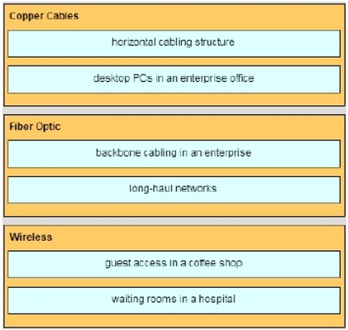](http://ccnav5.com/wp-content/uploads/2013/10/Clipboard015.jpg?csspreview=true)
2. **[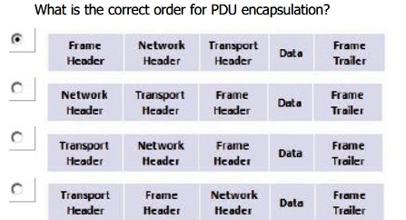](http://ccnav5.com/wp-content/uploads/2013/10/Clipboard011.jpg?csspreview=true)**

Rámcová Sieťová Transportná Data Rámcový  
 hlavička hlavička hlavička príves

1. **Which address on a PC does not change, even if the PC is moved to a different network?  
   MAC address**
2. **What will happen if the default gateway address is incorrectly configured on a host?  
   The host cannot communicate with hosts in other networks.**
3. **A host PC has just booted (naštartoval) and is attempting to lease an address through DHCP. Which two messages will the client typically broadcast (vysielanie) on the network? (Choose two.)  
   DHCP REQUEST (dhcp žiadosť)**  
   **DHCP DISCOVER**
4. [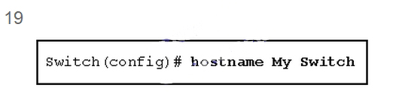](http://ccnav5.com/wp-content/uploads/2013/10/p19.jpg?csspreview=true)  
   Refer to the exhibit. An administrator wants to change the name of a brand new switch, using the hostname command as shown. What prompt will display after the command is issued?​  
   **Switch(config)#​**
5. **After making configuration changes, a network administrator issues (výdaj) a copy running-config startup-config command in a Cisco switch. What is the result of issuing this command?  
   The new configuration will be loaded if the switch is restarted.**
6. [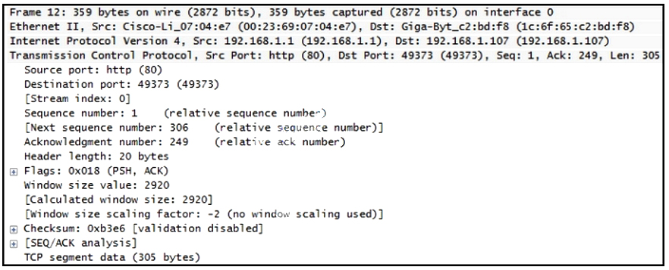](http://ccnav5.com/wp-content/uploads/2013/10/p21.jpg?csspreview=true)  
   Refer to the exhibit. A TCP segment from a server has been captured by Wireshark, which is running on a host. What acknowledgement number will the host return for the TCP segment that has been received?  
   **306**
7. **Which technology provides a solution (riešenie) to IPv4 address depletion by allowing multiple devices to share one public IP address?  
   NAT**
8. **What is the purpose (účel) of the routing process?  
   to select the paths that are used to direct traffic (prevádzka) to destination networks**
9. **Three bank employees are using the corporate network. The first employee uses a web browser to view a company web page in order to read some announcements. The second employee accesses the corporate database to perform some financial transactions. The third employee participates in an important live audio conference with other corporate managers in branch offices. If QoS is implemented on this network, what will be the priorities from highest to lowest of the different data types?  
   audio conference, financial transactions, web page**
10. **A home user is looking for an ISP connection that provides high speed digital transmission over regular phone lines. What ISP connection type should be used?  
    DSL**
11. **Which connection provides a secure CLI session with encryption (šifrovanie) to a Cisco switch?  
    an SSH connection**
12. **What is the purpose (účel) of the network security accounting (účet, konto) function?  
    to keep (udržiavať) track (trasa) of the actions of a user**
13. [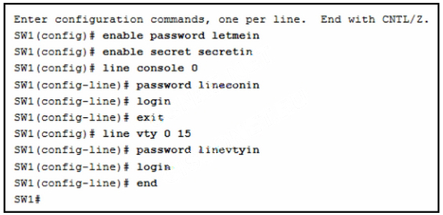](http://ccnav5.com/wp-content/uploads/2013/10/p28.jpg?csspreview=true)  
    **Refer to the exhibit. A network administrator is configuring access control to switch SW1. If the administrator uses Telnet to connect to the switch, which password is needed to access user EXEC mode?  
    linevtyin**
14. **Which publicly (verejné) available (dostupný) resources describe (popisujú) protocols, processes, and technologies for the Internet but do not give implementation details?  
    Request for Comments**
15. **A PC is configured to obtain an IP address automatically from network 192.168.1.0/24. The network administrator issues (výdaj) the arp –a command and notices an entry of 192.168.1.255 ff-ff-ff-ff-ff-ff. Which statement describes this entry?  
    This is a static map entry.**
16. Which subnet would include the address 192.168.1.96 as a usable host address?  
    **192.168.1.64/26**
17. 32 A particular (určitý) website does not appear (objaviť sa) to be responding on a Windows 7 computer. What command could the technician use to show any cached DNS entries for this web page?  
    **ipconfig /displaydns**
18. Which type of wireless security generates dynamic encryption keys each time a client associates with an AP?  
    **WPA**
19. A frame is transmitted from one networking device to another. Why does the receiving (prijímacie) device check the FCS field in the frame?  
    **to check the frame for possible transmission errors**
20. [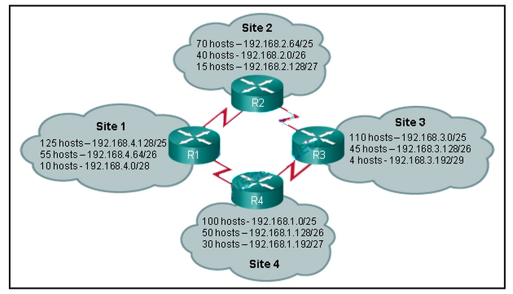](http://ccnav5.com/wp-content/uploads/2013/10/p351.jpg?csspreview=true)  
    Refer to the exhibit. Which IP addressing scheme should be changed?  
    **Site 2**
21. What is the effect of configuring the ipv6 unicast-routing command on a router?  
    **to enable (oprávniť) the router as an IPv6 router**
22. [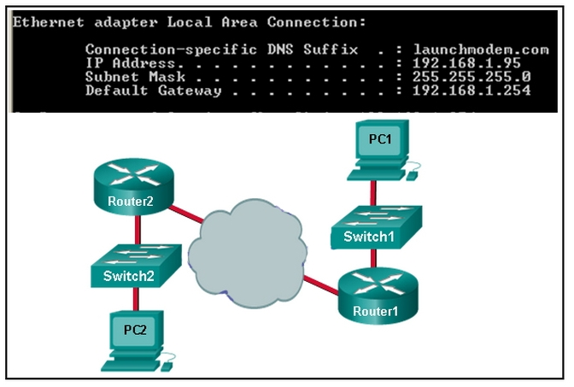](http://ccnav5.com/wp-content/uploads/2013/10/p381.jpg?csspreview=true)Which three IP addresses are private ? (Choose three.)  
    **10.1.1.1**  
    **172.16.4.4**  
    **192.168.5.5**

Refer to the exhibit. Consider the IP address configuration shown from PC1. What is a description of the default gateway address?  
**It is the IP address of the Router1 interface that connects the PC1 LAN to Router1.**

1. During (počas) normal operation, from which location do most Cisco switches and routers run the IOS?  
   **RAM**
2. What is an important function of the physical layer of the OSI model?  
   **It encodes frames into electrical, optical, or radio wave signals.**
3. Which procedure is used to reduce the effect of crosstalk in copper cables?  
   **twisting opposing circuit wire pairs together**
4. What are the three primary functions provided by Layer 2 data encapsulation? (Choose three.)  
   **detection of errors through CRC calculations**  
   **delimiting (vymedzujúci) groups of bits into frames**  
   **data link layer addressing**
5. What method is used to manage contention-based access on a wireless network?  
   **CSMA/CA**
6. What happens when part of an Internet radio transmission is not delivered to the destination?  
   **The transmission continues without the missing portion.**
7. What is the auto-MDIX feature on a switch?  
   **the automatic configuration of an interface for a straight-through or a crossover Ethernet cable connection**
8. Which function is provided by TCP?  
   **detection of missing packets**
9. How does a Layer 3 switch differ from a Layer 2 switch?  
   **An IP address can be assigned to a physical port of a Layer 3 switch. However, this is not supported in Layer 2 switches.**
10. Which two notations are useable nibble boundaries when subnetting in IPv6? (Choose two.)  
    **/68**  
    **/64**
11. What is the purpose of having a converged network?  
    **to reduce the cost of deploying and maintaining the communication infrastructure**
12. [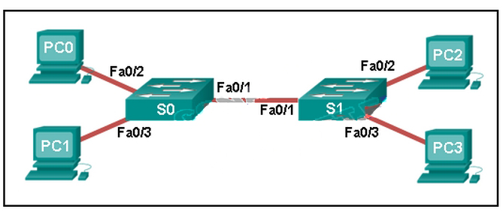](http://ccnav5.com/wp-content/uploads/2013/10/p50.jpg?csspreview=true)  
    Refer to the exhibit. A ping to PC3 is issued from PC0, PC1, and PC2 in this exact order. Which MAC addresses will be contained in the S1 MAC address table that is associated with the Fa0/1 port?  
    **just PC0 and PC1 MAC addresses**
13. Which field in an IPv4 packet header will typically stay the same during its transmission?  
    **Destination Address**
14. What two preconfigured settings that affect security are found on most new wireless routers? (Choose two.)  
    **default administrator password**  
    **broadcast SSID**
15. Which parameter does the router use to choose the path to the destination when there are multiple routes available?  
    **the lower metric value that is associated with the destination network**
16. [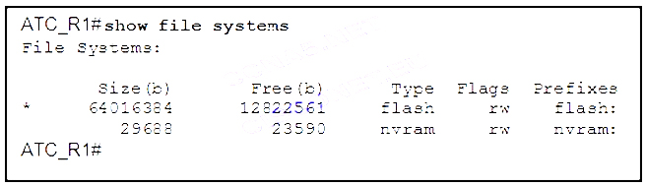](http://ccnav5.com/wp-content/uploads/2013/10/p54.jpg?csspreview=true)  
    Refer to the exhibit. What is the significance of the asterisk (*) in the exhibited output?  
    **The asterisk designates which file system is the default file system.**
17. [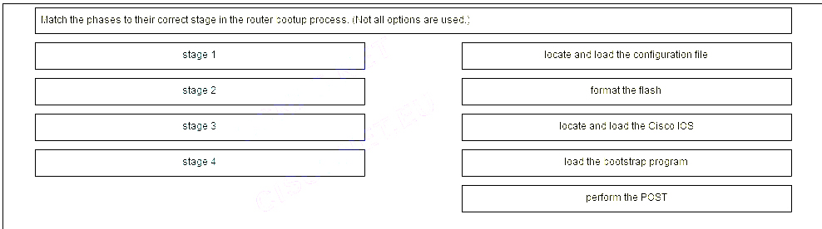](http://ccnav5.com/wp-content/uploads/2013/10/p55.jpg?csspreview=true)

[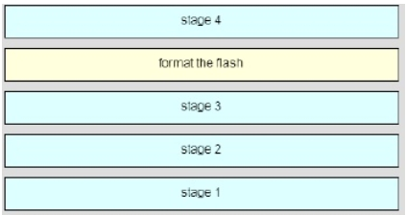](http://ccnav5.com/wp-content/uploads/2013/10/Clipboard013.jpg?csspreview=true)

1. Fill in the blank.  
   During data communications, a host may need to send a single message to a specific group of destination hosts simultaneously. This message is in the form of a **“multicast”** message.
2. An administrator uses the Ctrl-Shift-6 key combination on a switch after issuing the ping command. What is the purpose of using these keystrokes?  
   **to interrupt the ping process**
3. [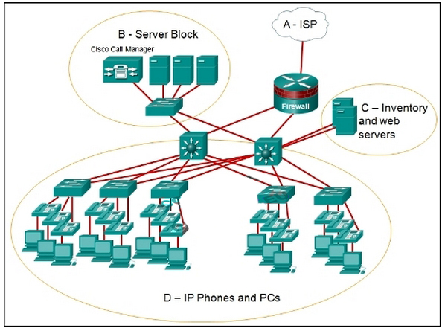](http://ccnav5.com/wp-content/uploads/2013/10/p581.jpg?csspreview=true)  
   Refer to the exhibit. Which area would most likely be an extranet for the company network that is shown?  
   **area C**
4. [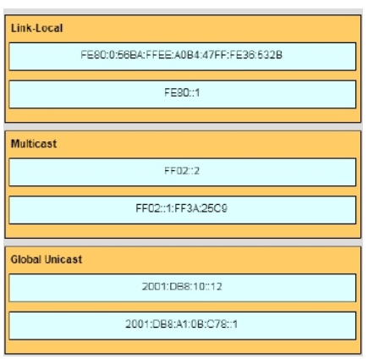](http://ccnav5.com/wp-content/uploads/2013/10/Clipboard014.jpg?csspreview=true)  
   [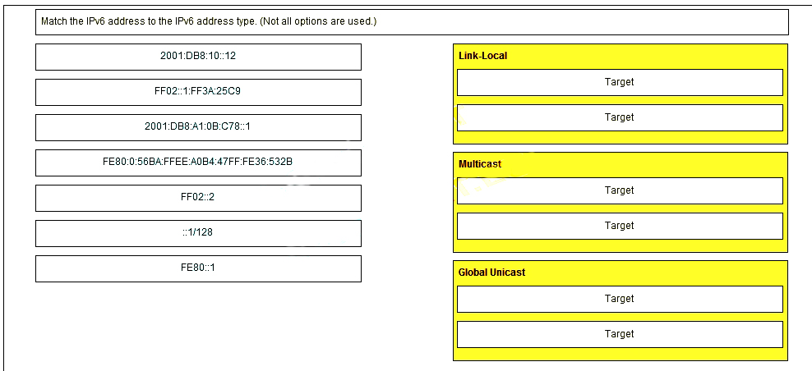](http://ccnav5.com/wp-content/uploads/2013/10/p59.jpg?csspreview=true)
5. [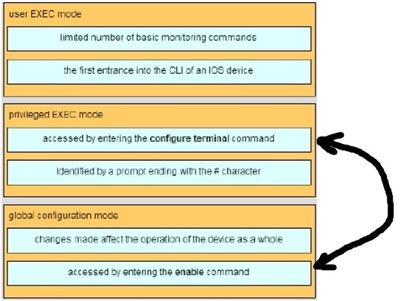](http://ccnav5.com/wp-content/uploads/2013/10/Clipboard0121.jpg?csspreview=true)[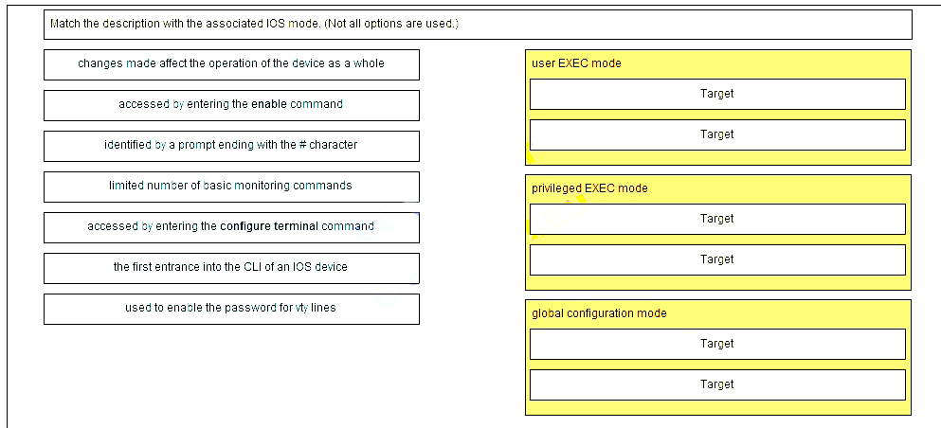](http://ccnav5.com/wp-content/uploads/2013/10/p60.jpg?csspreview=true)

1. In which default order will a router search for startup configuration information?  
   **NVRAM, TFTP, setup mode**
2. [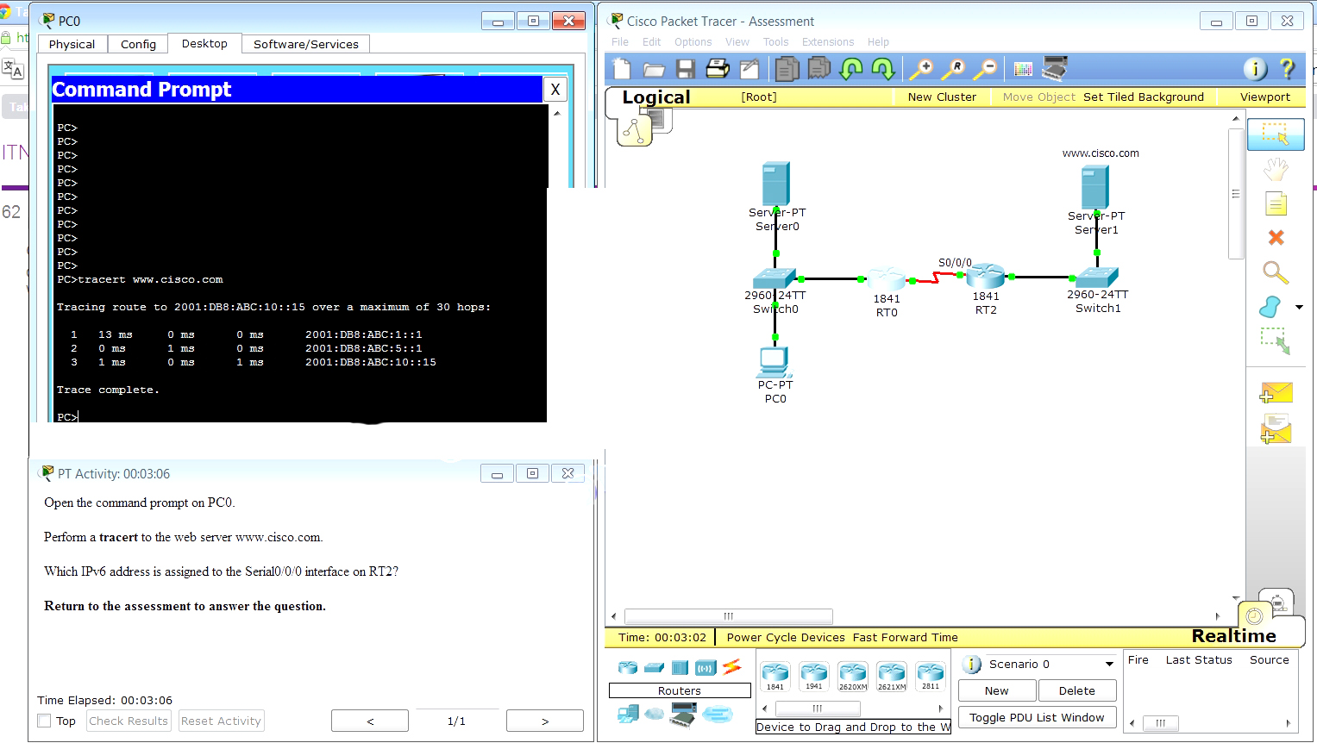](http://ccnav5.com/wp-content/uploads/2013/10/p62.jpg?csspreview=true)  
   Launch PT – Hide and Save PT  
   Open the PT Activity. Perform the tasks in the activity instructions and then answer the question.  
   Which IPv6 address is assigned to the Serial0/0/0 interface on RT2?  
   **2001:db8:abc:5::1**
3. The result of the tracert command is as follows:  
   1 11 ms 0 ms 0 ms 2001:db8:abc:1::1  
   2 4 ms 0 ms 1 ms 2001:db8:abc:5::1  
   3 11 ms 14 ms 2 ms 2001:db8:abc:10::15  
   It crosses two routers, so the second line is the IP address for the RT2 serial interface0/0/0.
4. A network administrator is designing a new network infrastructure that includes both wired and wireless connectivity. Under which situation would a wireless connection be recommended?
   * **The end-user device needs mobility when connecting to the network.\***
5. A user is attempting to do an http://www.cisco.com/ without success. Which two configuration values must be set on the host to allow this access? (Choose two.)

**DNS server\***

**default gateway\***

1. Which two statements are correct in a comparison of IPv4 and IPv6 packet headers? (Choose two.)

**The Source Address field name from IPv4 is kept in IPv6.\***

**The Time-to-Live field from IPv4 has been replaced by the Hop Limit field in IPv6.\***

1. A user calls the help desk to report that a Windows XP workstation is unable to connect to the network after startup and that a popup window says “This connection has limited or no connectivity.” The technician asks the user to issue the ipconfig /all command. The user reports the IP address is 169.254.69.196 with subnet mask of 255.255.0.0 and nothing is displayed for the DNS server IP address. What is the cause of the problem?

**The workstation is unable to obtain an IP address from a DHCP server.\***

1. A network administrator has been issued a network address of 192.31.7.64/26. How many subnets of equal size could be created from the assigned /26 network by using a /28 prefix?

**4\***

1. Why are port numbers included in the TCP header of a segment?

**to enable a receiving host to forward the data to the appropriate application\***

1. 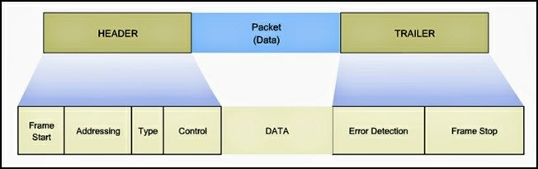

Refer to the exhibit. Which layer of the OSI model would format data in this way?

**data link\***

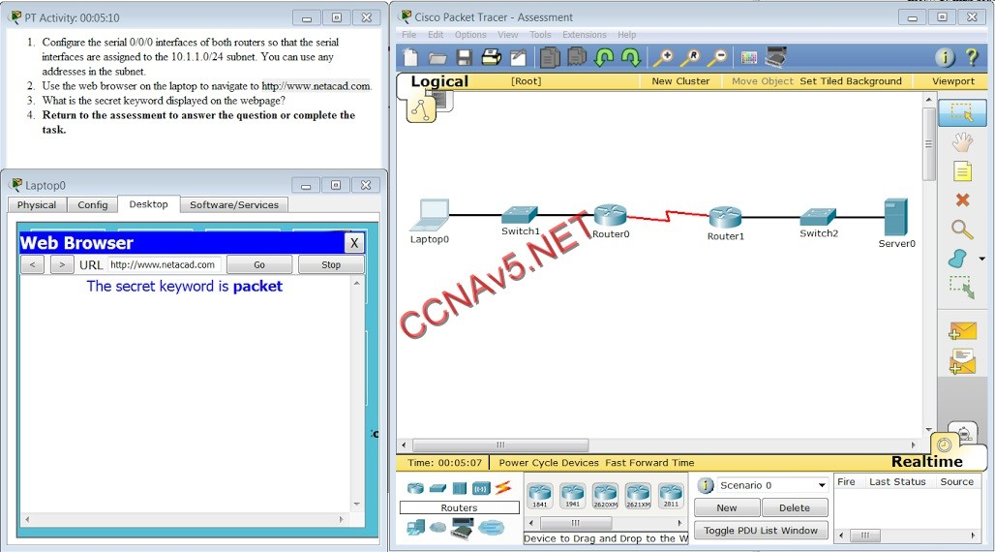

Open the PT Activity. Perform the tasks in the activity instructions and then answer the question.

What is the secret keyword that is displayed on the web page?

**packet\***

1. Which two types of applications rely on their traffic having priority over other traffic types through the network? (Choose two.)

**Voice**

**Video**

1. Fill in the blank.

In dotted decimal notation, the IP address **“172.25.0.126″** is the last host address for the network 172.25.0.64/26.

1. Which devices should be secured to mitigate against MAC address spoofing attacks?

**Layer 2 devices\***

1. Which IPv6 address notation is valid?

**2001:DB8:0:1111::200\***

1. To revert to a previous configuration, an administrator issues the command copy tftp startup-config on a router and enters the host address and file name when prompted. After the command is completed, why does the current configuration remain unchanged?

**The configuration should have been copied to the running configuration instead.\***

1. What are two characteristics of a scalable network? (Choose two.)

**grows in size without impacting existing users\***

**suitable for modular devices that allow for expansion\***

1. Which two functions are primary functions of a router? (Choose two.)

**packet switching\***

**path selection\***

1. Using default settings, what is the next step in the router boot sequence after the IOS loads from flash?

**Locate and load the startup-config file from NVRAM.\***

1. A router boots and enters setup mode. What is the reason for this?

**The configuration file is missing from NVRAM.\***

1. What is an ISP?

**It is an organization that enables individuals and businesses to connect to the Internet.\***

1. 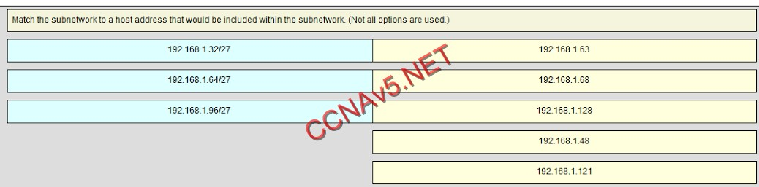

Subnet 192.168.1.32/27 will have a valid host range from 192.168.1.33 – 192.168.1.62 with the broadcast address as 192.168.1.63  
Subnet 192.168.1.64/27 will have a valid host range from 192.168.1.65 – 192.168.1.94 with the broadcast address as 192.168.1.95  
Subnet 192.168.1.96/27 will have a valid host range from 192.168.1.97 – 192.168.1.126 with the broadcast address as 192.168.1.127

1. What information is added during encapsulation at OSI Layer 3?

**source and destination IP address\***

1. What are two ways that TCP uses the sequence numbers in a segment? (Choose two.)

**to reassemble the segments at the remote location\***

**to identify missing segments at the destination\***

1. Which statement describes a characteristic of the traceroute utility?

**It identifies the routers in the path from a source host to a destination host.\***

1. 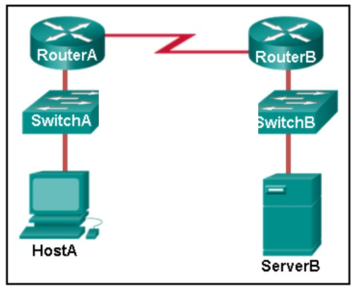

Refer to the exhibit. HostA is attempting to contact ServerB. Which two statements correctly describe the addressing that HostA will generate in the process? (Choose two.)

**A frame with the destination MAC address of RouterA.\***

**A packet with the destination IP address of ServerB**

1. For which three reasons was a packet-switched connectionless data communications technology used when developing the Internet? (Choose three.)

**It can rapidly adapt to the loss of data transmission facilities.\***

**It efficiently utilizes the network infrastructure to transfer data.\***

**Data packets can travel multiple paths through the network simultaneously.\***

1. A network administrator is troubleshooting connectivity issues on a server. Using a tester, the administrator notices that the signals generated by the server NIC are distorted and not usable. In which layer of the OSI model is the error categorized?

**physical layer\***

1. What will a host on an Ethernet network do if it receives a frame with a destination MAC address that does not match its own MAC address?

**It will discard the frame.\***

1. What are the three parts of an IPv6 global unicast address? (Choose three.)

**global routing prefix**\*

**subnet ID\***

**interface ID\***

1. A PC that is communicating with a web server is utilizing a window size of 6,000 bytes when sending data and a packet size of 1,500 bytes. What byte of information will the web server acknowledge after it has received four packets of data from the PC?

**6,001\***

1. What three primary functions does data link layer encapsulation provide? (Choose three.)

**error detection\***

**addressing\***

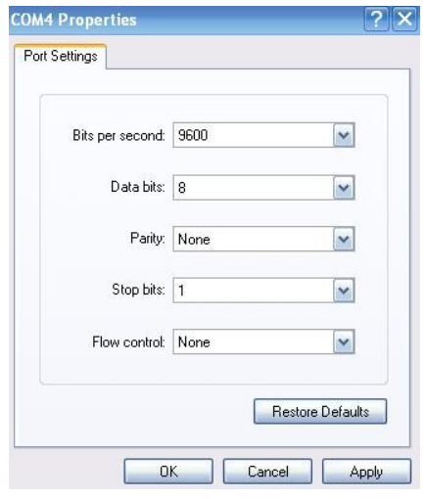**frame delimiting\***

1. Refer to the exhibit. A network engineer is attempting to connect to a new router to perform the initial configuration. The engineer connects a rollover cable from the serial port of a PC to the Aux port on the router, then configures HyperTerminal as shown. The engineer cannot get a login prompt in HyperTerminal. What would fix the problem?

**Move the cable to the router console port.\***

1. The administrator of a branch office receives an IPv6 prefix of 2001:db8:3000::/52 from the corporate network manager. How many subnets can the administrator create?

**4096\***

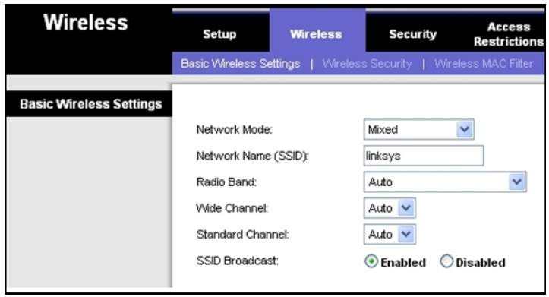

1. Refer to the exhibit. Which two settings could be changed to improve security on the wireless network? (Choose two.)

**SSID\***

**SSID broadcast\***

1. Fill in the blank using a number.

The minimum Ethernet frame size is **“64”** bytes. Anything smaller than that should be considered a “runt frame.”

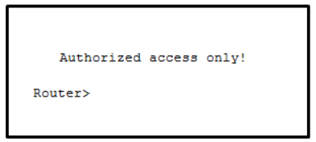

1. Refer to the exhibit. From global configuration mode, an administrator is attempting to create a message-of-theday banner by using the command banner motd V Authorized access only! Violators will be prosecuted! V When users log in using Telnet, the banner does not appear correctly. What is the problem?

**The delimiting character appears in the banner message.\***

1. Which router configuration mode would an administrator use to configure the router for SSH or Telnet login access?

**line\***

1. Which service will translate private internal IP addresses into Internet routable public IP addresses?

**NAT\***

1. What three statements describe features or functions of media access control? (Choose three.)

**Ethernet utilizes CSMA/CD.\***

**Data link layer protocols define the rules for access to different media.\***

**It is responsible for detecting transmission errors in transmitted data.\***

1. Fill in the blank. Do not abbreviate. Use lower case.

Which interface configuration mode command puts a Layer 3 switch interface into Layer 3 mode?

**” no switchport ”**

1. 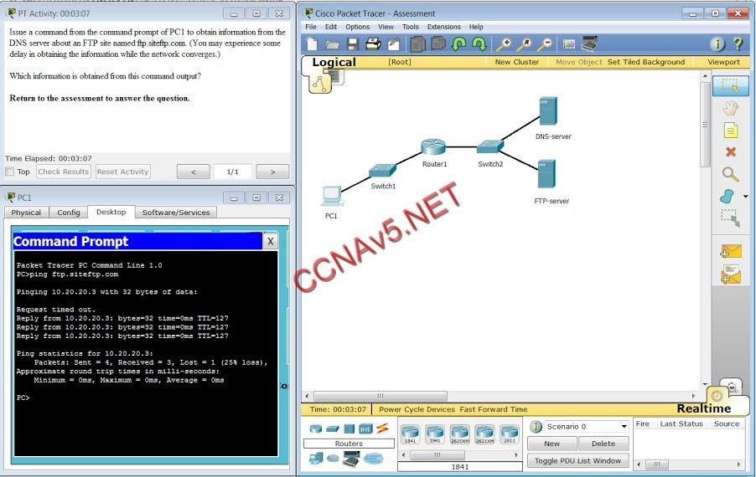

Open the PT activity. Perform the tasks in the activity instructions and then answer the question.

Which information is obtained from this command output?

**10.20.20.3, non-authoritative answer\***

1. A small satellite office has been given the overall network number of 192.168.99.0/24 and the network technician can subdivide the network addresses as needed. The office needs network access for both wired and wireless devices. However, because of the security consideration, these two networks should be separate. The wired network will have 20 devices. The wireless network has a potential connection of 45 devices. Which addressing scheme would be most efficient for these two networks?

**192.168.99.0/26**

**192.168.99.64/27 \*\*\*\*\*\*\*\*\*\*\*\*\*\***

1. What makes fiber preferable to copper cabling for interconnecting buildings? (Choose three.)

**greater bandwidth potential\***

**limited susceptibility to EMI/RFI\***

**greater distances per cable run\***

1. A network team is comparing physical WAN topologies for connecting remote sites to a headquarters building. Which topology provides high availability and connects some, but not all, remote sites?

**partial mesh\***

1. What is the function of CSMA/CA in a WLAN?

**It provides the mechanism for media access.\***

1. A network administrator enters the service password-encryption command into the configuration mode of a router. What does this command accomplish?

**This command prevents someone from viewing the running configuration passwords.\***

1. Fill in the blank.

A nibble consists of “**4**” bits.

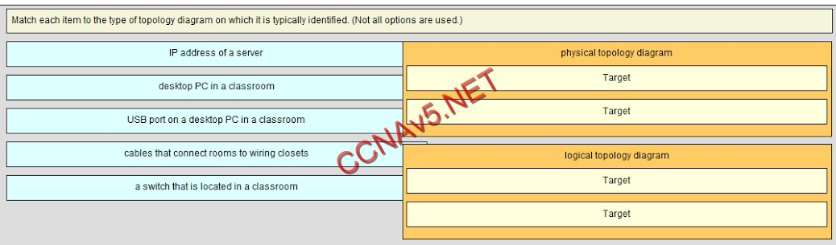

Place the options in the following order:

**[+] cables connecting rooms to wiring closets**

**[+] desktop PC in a classroom**

**[#] IP address of a server**

**[#] a switch located in a classroom**

1. Why are the paired wires twisted in a CAT5 cable?

**to provide eletromagnetic noise cancellation\***

1. A medium-sized business is researching available options for connecting to the Internet. The company is looking for a high speed option with dedicated, symmetric access. Which connection type should the company choose?

**leased line\***

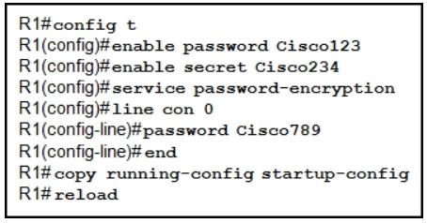

1. Refer to the exhibit. What will be the result of entering this configuration the next time a network administrator connects a console cable to the router and no additional commands have been entered?

**The administrator will be presented with the R1> prompt.\***

1. The ARP table in a switch maps which two types of address together?

**Layer 3 address to a Layer 2 address\***

1. Which is a function of the show ip route command when used as a tool for troubleshooting network connectivity?

**shows the IP address of the next hop router for each route\***

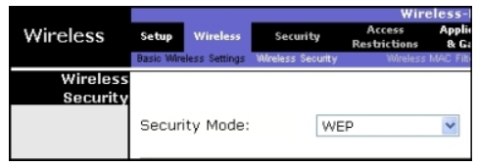

1. Refer to the graphic. What is the effect of setting the security mode to WEP on the Linksys integrated router?

**It encrypts data between the wireless client and the access point.\***

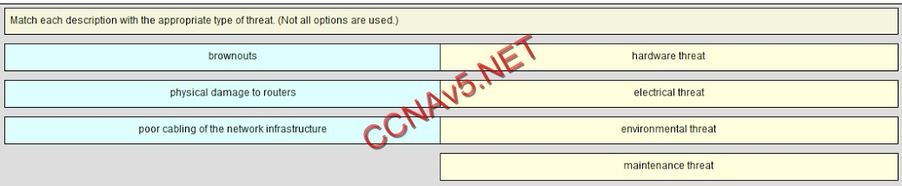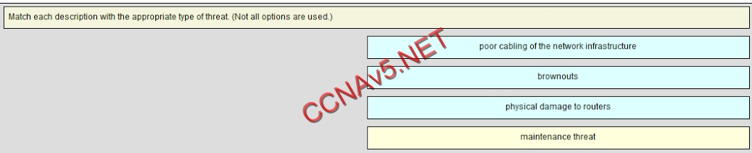

1. What are two actions performed by a Cisco switch? (Choose two.)

**utilizing the MAC address table to forward frames via the destination MAC address\***

**using the source MAC addresses of frames to build and maintain a MAC address table\***

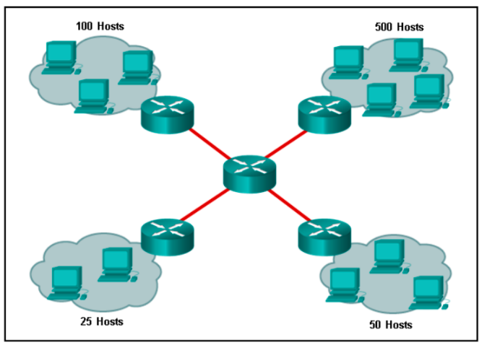

1. Refer to the exhibit. Using VLSM, what is the largest and smallest subnet mask required on this network in order to minimize address waste?

**255.255.254.0 and 255.255.255.252\***

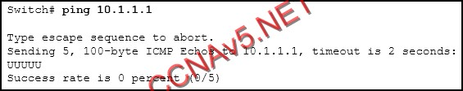

Refer to the exhibit. An administrator is testing connectivity to a remote device with the IP address 10.1.1.1. What does the output of this command indicate?

**A router along the path did not have a route to the destination.\***

1. What is one purpose of the TCP three-way handshake?

**synchronizing sequence numbers between source and destination in preparation for data transfer\***

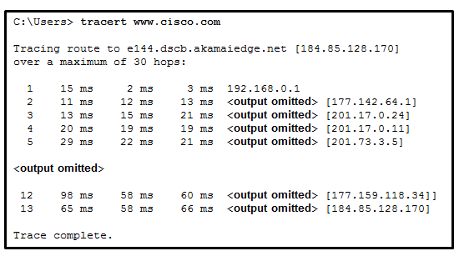

1. **Refer to the exhibit. What is the maximum TIL value that is used to reach the destination www.cisco.com?**  
   **13\***
2. **Which IPv4 address can be pinged to test the internal TCP/IP operation of a host?**  
   **127.0.0.1\***
3. **A host is accessing a Telnet server on a remote network. Which three functions are performed by intermediary network devices during this conversation? (Choose three.)**  
   **regenerating data signals\***  
   **applying security settings to control the ftow of data\***  
   **notifying other devices when errors occur\***
4. **Which statement is true about DHCP operation?**  
   **When a device that is configured to use DHCP boots, the client broadcasts a  
   DHCPDISCOVER message to identify any available DHCP servers on the networK.\***
5. **Which type of wireless security is easily compromised?**  
   **WEP\***
6. **What types of addresses make up the majority of addresses within the /8 block 1Pv4 bit space?**  
   **public addresses\***
7. **Which protocol supports rapid delivery of streaming media?**  
   **Transmission Control Protocol\***
8. **A network administrator notices that the throughput on the network appears lower than expected when compared to the end-to-end network bandwidth. Which three factors can**  
   **explain this difference? (Choose three.)**  
   **the amount of traffic\***  
   **the type of traffic\***  
   **the number and type of network devices that the data is crossing\***
9. **Which group of IPv6 addresses cannot be allocated as a host source address?**  
   **FF00::/8\***
10. **A host PC is attempting to lease an address through DHCP. What message is sent by the server to the client know it is able to use the provided IP information?**  
    **DHCPOFFER\***
11. **What is contained in the trailer of a data-link frame?  
    error detection\***
12. 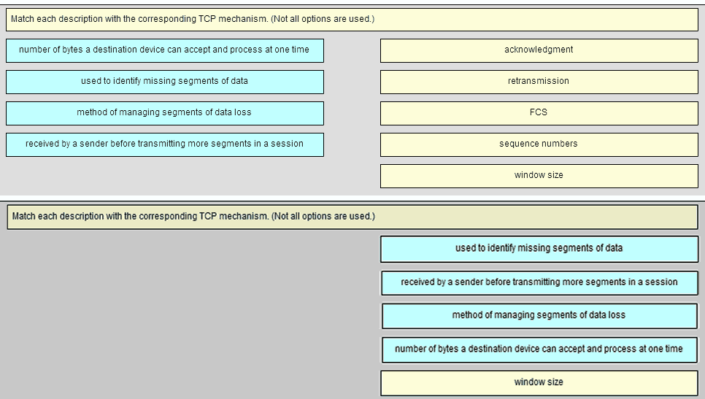
13. **What is the protocol that is used to discover a physical address from a known logical address and what message type does it use?**  
    **ARP, broadcast\***
14. **Which group of IPv6 addresses cannot be allocated as a host source address??**  
    **FF00::/8 (multicast)\***
15. **A network administrator is configuring access control to switch SW1. If the administrator uses console line to connect to the switch, which password is needed to access user EXEC mode?**  
    **-lineconin\***
16. **A _________ topology influences the type of network framing and media access control that will be used. (logical*)**
17. **Which two statements describe the characteristics of fiber-optic cabling? (Choose two.)**  
    **Fiber-optic cabling does not conduct electricity.\***  
    **Fiber-optic cabling is primarily used as backbone cabling.\***
18. **3 Which two protocols function at the internet layer? (Choose two.)**  
    **ICMP\***  
    **IP\***
19. **4 Which firewall technique blocks incoming packets unless they are responses to internal requests?**  
    **stateful packet inspection\***
20. **5 Consider the following range of addresses:**  
    2001:0DB8:BC15:00A0:0000::  
    2001:0DB8:BC15:00A1:0000::  
    2001:0DB8:BC15:00A2:0000::  
    …  
    2001:0DB8:BC15:00AF:0000::  
    **The prefix-length for the range of addresses is ___. (/60*)**
21. **6 What three application layer protocols are part of the TCP/IP protocol suite? (Choose three.)**  
    **FTP\***  
    **DHCP\***  
    **DNS\***
22. **7 Which communication tool allows real-time collaboration?**  
    **instant messaging\***
23. **8 Which of the following are primary functions of a router? (Choose two.)**  
    **packet switching\***  
    **path selection\***
24. 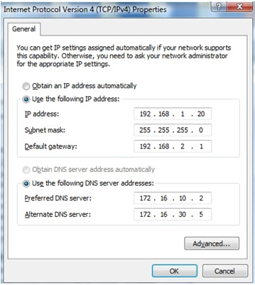**9 __________ is a best-effort, connectionless application layer protocol that is used to transfer files. (TFTP*)**
25. Refer to the exhibit. A technician has configured a user workstation with the IP address and default subnet masks that are shown. Although the user can access all local LAN resources, the user cannot access any Internet sites by using either FQDN or IP addresses. Based upon the exhibit, what could account for this failure?

**The default gateway address in incorrect.**

1. 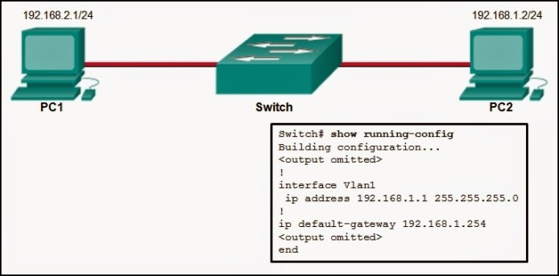**It will give 4 options about ping, the correct one is: The PC2 will be able to ping 192.168.1.1\***

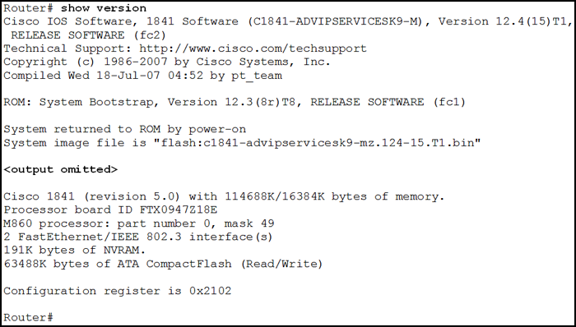

1. Refer to the exhibit. From which location did this router load the IOS?  
   **flash memory**

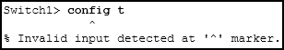

1. Refer to the exhibit. An administrator is trying to configure the switch but receives the error message that is displayed in the exhibit. What is the problem?

**The administrator must first enter privileged EXEC mode before issuing the command.**

1. **What are three characteristics of multicast transmission? (Choose three.)**

**A single packet can be sent to a group of hosts.\***

**Multicast messages map lower layer addresses to upper layer addresses.\***

**Multicast transmission can be used by routers to exchange routing information.\***

1. **At a minimum, which address is required on IPv6-enabled interfaces?**

**link-local\***

1. **Which frame forwarding method receives the entire frame and performs a CRC check to detect errors before forwarding the frame?**

**store-and-forward switching\***

63. Which two commands should be implemented to return a Cisco 3560 trunk port to its default configuration? (Choose two.)  
**S1(config-if)# no switchport trunk native vlan**  
**S1(config-if)# no switchport trunk allowed vlan**

64. Which command will enable auto-MDIX on a device?  
**S1(config-if)# mdix auto**

65. Which three parameters could be in an extended access control list? (Choose three.)  
**destination address and wildcard mask**  
**source address and wildcard mask**  
**access list number between 100 and 199**

66. Fill in the blank.  
The OSPF Type 1 packet is the **hello**​ packet.

67. The computers used by the network administrators for a school are on the 10.7.0.0/27 network. Which two commands are needed at a minimum to apply an ACL that will ensure that only devices that are used by the network administrators will be allowed Telnet access to the routers? (Choose two.)  
**ip access-group 5 in  
access-list 5 permit 10.7.0.0 0.0.0.31**

68. What address type will OSPFv3 use to form adjacency to neighboring routers?  
the all-link router multicast  
the all OSPF router multicast  
the global unicast of the interface  
the link-local address of the interface

69. Why would an administrator use a network security auditing tool to flood the switch MAC address table with fictitious MAC addresses?  
**to determine which ports are not correctly configured to prevent MAC address flooding**

70. Which two statements are true about half-duplex and full-duplex communications? (Choose two.)  
**Full duplex offers 100 percent potential use of the bandwidth.  
Full duplex allows both ends to transmit and receive simultaneously.**

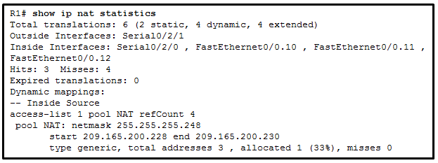

Refer to the exhibit. A network administrator has just configured address translation and is verifying the configuration. What three things can the administrator verify? (Choose three.)  
**A standard access list numbered 1 was used as part of the configuration process.**  
**Address translation is working.**  
**Two types of NAT are enabled.**

72. A network administrator is implementing a distance vector routing protocol between neighbors on the network. In the context of distance vector protocols, what is a neighbor?  
**routers that share a link and use the same routing protocol**  
72. Which two methods can be used to provide secure management access to a Cisco switch? (Choose two.)  
**Configure SSH for remote management.  
Configure specific ports for management traffic on a specific VLAN.**

3. What is the protocol that is used to discover a physical address from a known logical address and what message type does it use?  
**ARP, broadcast**

4. A network administrator is configuring access control to switch SW1. If the administrator uses console line to connect to the switch, which password is needed to access user EXEC mode?  
**lineconin**

75. A **logical** topology influences the type of network framing and media access control that will be used.

76. Which two statements describe the characteristics of fiber-optic cabling? (Choose two.)  
**Fiber-optic cabling does not conduct electricity.**  
**Fiber-optic cabling is primarily used as backbone cabling.**

77. Which two protocols function at the internet layer? (Choose two.)  
**ICMP**  
**IP**

78. Which firewall technique blocks incoming packets unless they are responses to internal requests?  
**stateful packet inspection**

79. Consider the following range of addresses:  
2001:0DB8:BC15:00A0:0000::  
2001:0DB8:BC15:00A1:0000::  
2001:0DB8:BC15:00A2:0000::  
2001:0DB8:BC15:00AF:0000::

The prefix-length for the range of addresses is **/60**.

80. What three application layer protocols are part of the TCP/IP protocol suite? (Choose three.)  
**FTP**  
**DHCP**  
**DNS**

81. Which communication tool allows real-time collaboration?  
**instant messaging**

82. Which of the following are primary functions of a router? (Choose two.)  
**packet switching**  
**path selection**

83. **TFTP** is a best-effort, connectionless application layer protocol that is used to transfer files.

87. What are three characteristics of multicast transmission? (Choose three.)  
**A single packet can be sent to a group of hosts.  
Multicast messages map lower layer addresses to upper layer addresses.  
Multicast transmission can be used by routers to exchange routing information.**

88. At a minimum, which address is required on IPv6-enabled interfaces?  
**link-local**

89. Which frame forwarding method receives the entire frame and performs a CRC check to detect errors before forwarding the frame?  
**store-and-forward switching**

90.A company is expanding its business to other countries. All branch offices must remain connected to corporate headquarters at all times. Which network technology is required to support this requirement?  
**WAN**

Which connection provides a secure CLI session with encryption to a Cisco network device?  
**an SSH connection**

What function does pressing the Tab key have when entering a command in IOS?  
**It completes the remainder of a partially typed word in a command.**

Which IPv4 address can be pinged to test the internal TCP/IP operation of a host?

**127.0.0.1**

99.  
How many bits make up the single IPv6 hextet :10CD:?

4  
8  
16  
32

100.  
Which group of IPv6 addresses cannot be allocated as a host source address?​

FEC0::/10​  
FDFF::/7​  
FEBF::/10​  
FF00::/8

A network administrator needs to monitor network traffic to and from servers in a data center. Which features of an IP addressing scheme should be applied to these devices?

**predictable static IP addresses for easier identification**

When is a dial-up connection used to connect to an ISP?

**when a regular telephone line is used**

On a school network, students are surfing the web, searching the library database, and attending an audio conference with their sister school in Japan. If network traffic is prioritized with QoS, how will the traffic be classified from highest priority to lowest priority?

**audio conference, database, HTTP**

 During normal operation, from which location do most Cisco routers run the IOS?  
**RAM**

108. Which keys act as a hot key combination that is used to interrupt an IOS process?

**Ctrl-Shift-6**

109. After making configuration changes on a Cisco switch, a network administrator issues a copy running-config startup-config command. What is the result of issuing this command?

**The new configuration will be loaded if the switch is restarted.**

Which characteristics describe fiber optic cable? (Choose two.)  
**It is not affected by EMI or RFI.**  
**It is the most expensive type of LAN cabling.**

What are two features of a physical, star network topology? (Choose two.)

**It is straightforward to troubleshoot.**  
**It is easy to add and remove end devices.**

Which switching method has the lowest level of latency?

**fast-forward**

116. Which two statements describe the functions or characteristics of ROM in a router? (Choose two.)

**maintains instructions for POST diagnostics**  
**stores bootstrap program**

117. Which statement describes a characteristic of the Cisco router management ports?

**A console port is not used for packet forwarding.**

118. What is the dotted decimal representation of the IPv4 address 11001011.00000000.01110001.11010011?

**203.0.113.211**

120. What types of addresses make up the majority of addresses within the /8 block IPv4 bit space?

**public addresses**

 A company has a network address of 192.168.1.64 with a subnet mask of 255.255.255.192. The company wants to create two subnetworks that would contain 10 hosts and 18 hosts respectively. Which two networks would achieve that? (Choose two.)

**192.168.1.64/27**  
**192.168.1.96/28**

In a network that uses IPv4, what prefix would best fit a subnet containing 100 hosts?

**/25**

124. Which protocol supports rapid delivery of streaming media?

**Real-Time Transport Protocol**

125. Why would a network administrator use the tracert utility?

**to identify where a packet was lost or delayed on a network**

126. Which WLAN security protocol generates a new dynamic key each time a client establishes a connection with the AP?

**WPA**

127. Fill in the blank.  
Point-to-point communications where both devices can transmit and receive on the medium at the same time are known as **full-duplex**.

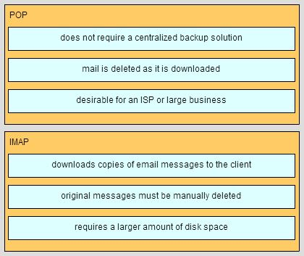

A host is accessing a Telnet server on a remote network. Which three functions are performed by intermediary network devices during this conversation? (Choose three.)

**regenerating data signals**  
**applying security settings to control the flow of data  
notifying other devices when errors occur**

131. A network administrator is making changes to the configuration of a router. After making the changes and verifying the results, the administrator issues the copy running-config startup-config command. What will happen after this command executes?

**The configuration will be copied to flash.**

132. What information does the loopback test provide?

**The device has the correct IP address on the network.**

133. What happens when a switch receives a frame and the calculated CRC value is different than the value that is in the FCS field?  
**The switch drops the frame.**

134. Which destination address is used in an ARP request frame?  
**FFFF.FFFF.FFFF**

135. What are the two main components of Cisco Express Forwarding (CEF)? (Choose two.)

**forwarding information base (FIB)**

136. Which statement describes the sequence of processes executed by a router when it receives a packet from a host to be delivered to a host on another network?  
**It de-encapsulates the packet and forwards it toward the destination host.**

137.  
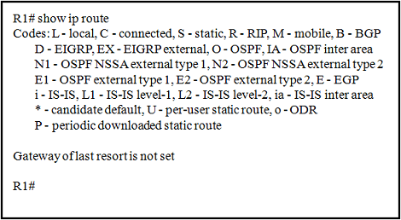  
Refer to the exhibit. Router R1 has two interfaces that were configured with correct IP addresses and subnet masks. Why does the show ip route command output not display any information about the directly connected networks?​CCNA1_Final_Exam_008

**The no shutdown command was not issued on these interfaces.**

138. What happens when part of an Internet television transmission is not delivered to the destination?

**The transmission continues without the missing portion.**

139. A user opens three browsers on the same PC to access www.cisco.com to search for certification course information. The Cisco web server sends a datagram as a reply to the request from one of the web browsers. Which information is used by the TCP/IP protocol stack in the PC to identify the destination web browser?  
**the destination port number**

140. Which statement is true regarding the UDP client process during a session with a server?

**Datagrams that arrive in a different order than that in which they were sent are not placed in order.**

141. Which two components are configured via software in order for a PC to participate in a network environment? (Choose two.)

**IP address**  
**subnet mask**

142. Which two reasons generally make DHCP the preferred method of assigning IP addresses to hosts on large networks? (Choose two.)  
**It eliminates most address configuration errors.  
It reduces the burden on network support staff.**

143. What is the subnet address for the address 2001:DB8:BC15:A:12AB::1/64?  
**2001:DB8:BC15:A::0**

144. Which two tasks are functions of the presentation layer? (Choose two.)  
**compression**  
**encryption**

145. Match the description with the associated IOS mode. (Not all options are used.)  
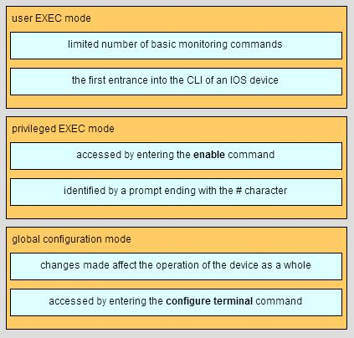

146. Match the IPv6 address to the IPv6 address type. (Not all options are used.)  
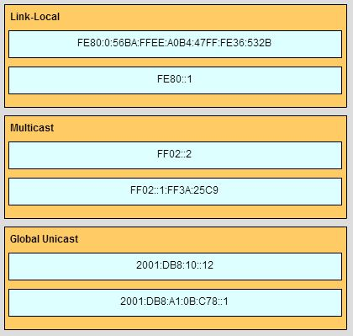

7. A college marketing department has a networked storage device that uses the IP address 10.18.7.5, TCP port 443 for encryption, and UDP port 4365 for video streaming. The college already uses PAT on the router that connects to the Internet. The router interface has the public IP address of 209.165.200.225/30. The IP NAT pool currently uses the IP addresses ranging from 209.165.200.228-236. Which configuration would the network administrator add to allow this device to be accessed by the marketing personnel from home?

**ip nat inside source static tcp 10.18.7.5 443 209.165.200.225 443  
ip nat inside source static udp 10.18.7.5 4365 209.165.200.225 4365**

14. A **logical** topology influences the type of network framing and media access control that will be used.

22.A network administrator is adding ACLs to a new IPv6 multirouter environment. Which IPv6 ACE is automatically added implicitly at the end of an ACL so that two adjacent routers can discover each other?

**permit icmp any any nd-na**

45. A network administrator is designing an ACL. The networks 192.168.1.0/25, 192.168.0.0/25, 192.168.0.128/25, 192.168.1.128/26, and 192.168.1.192/26 are affected by the ACL. Which wildcard mask, if any, is the most efficient to use when specifying all of these networks in a single ACL permit entry?

0.0.0.127  
0.0.0.255  
**0.0.1.255**  
0.0.255.255

**46. A network administrator is explaining to a junior colleague the use of the lt and gt keywords when filtering packets using an extended ACL. Where would the lt or gt keywords be used?**

**in an IPv4 extended ACL that allows packets from a range of TCP ports destined for a specific network device**

.A network administrator is using the router-on-a-stick method to configure inter-VLAN routing. Switch port Gi1/1 is used to connect to the router. Which command should be entered to prepare this port for the task?

**Switch(config)# interface gigabitethernet 1/1  
Switch(config-if)# switchport mode trunk**

12. A network contains multiple VLANs spanning multiple switches. What happens when a device in VLAN 20 sends a broadcast Ethernet frame?  
**Only devices in VLAN 20 see the frame.**

8. A small-sized company has 20 workstations and 2 servers. The company has been assigned a group of IPv4 addresses 209.165.200.224/29 from its ISP. What technology should the company implement in order to allow the workstations to access the services over the Internet? DYNAMIC NAT

**9.A router has used the OSPF protocol to learn a route to the 172.16.32.0/19 network. Which command will implement a backup floating static route to this network?**

**ip route 172.16.32.0 255.255.224.0 S0/0/0 200**

A router needs to be configured to route within OSPF area 0. Which two commands are required to accomplish this? (Choose two.)

**RouterA(config)# router ospf 1**  
**RouterA(config-router)# network 192.168.2.0 0.0.0.255 area 0**

29. A small-sized company has 20 workstations and 2 servers. The company has been assigned a group of IPv4 addresses 209.165.200.224/29 from its ISP. What technology should the company implement in order to allow the workstations to access the services over the Internet?

**port address translation**

28 At a minimum, which address is required on IPv6-enabled interfaces?  
**link-local**

18. Consider the following range of addresses:  
2001:0DB8:BC15:00A0:0000::  
2001:0DB8:BC15:00A1:0000::  
2001:0DB8:BC15:00A2:0000::  
2001:0DB8:BC15:00AF:0000::

The prefix-length for the range of addresses is **/60**.

13. A network administrator is configuring access control to switch SW1. If the administrator uses console line to connect to the switch, which password is needed to access user EXEC mode?  
**lineconin**

9. A network administrator is explaining to a junior colleague the use of the **lt** and **gt** keywords when filtering packets using an extended ACL. Where would the **lt** or **gt** keywords be used?

**in an IPv4 extended ACL that allows packets from a range of TCP ports destined for a specific network device**

10. A network administrator is implementing a distance vector routing protocol between neighbors on the network. In the context of distance vector protocols, what is a neighbor?  
**routers that share a link and use the same routing protocol**

23. Can not connect to webpages, dns is ok.  
  
Issue is: **Default Gateway**.

2.Fill in the blank.  
In IPv6, all routes are level **1** ultimate routes.

41. Fill in the blank.

Static routes are configured by the use of the **ip route** global configuration command.

42. Fill in the blank.

The default administrative distance for a static route is **1**.

4. Fill in the blank.  
The OSPF Type 1 packet is the **hello**​ packet.

16. How is the router ID for an OSPFv3 router determined?

**the highest IPv4 address on an active interface**

26. It will ask what is the issue.

Answer is:  
**The user has to be in privileged EXEC mode to use that command.**

24. It will give 4 options about ping, the correct one is: **The PC2 will be able to ping 192.168.1.1**



43. Match the order in which the link-state routing process occurs on a router. (Not all options are used.)  
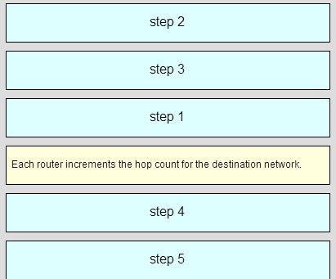

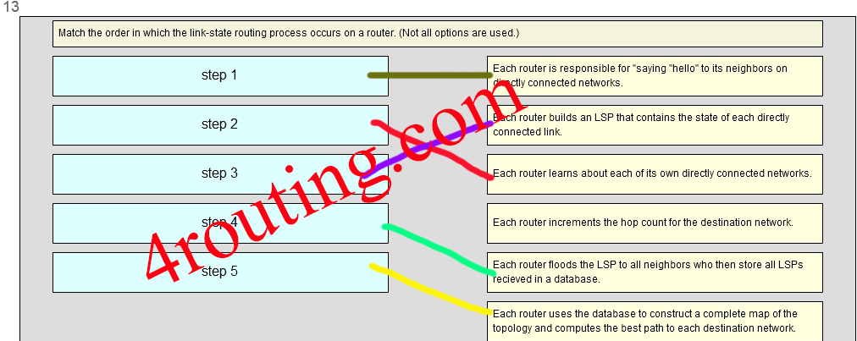platia čierne šípočky pre step1 a 2

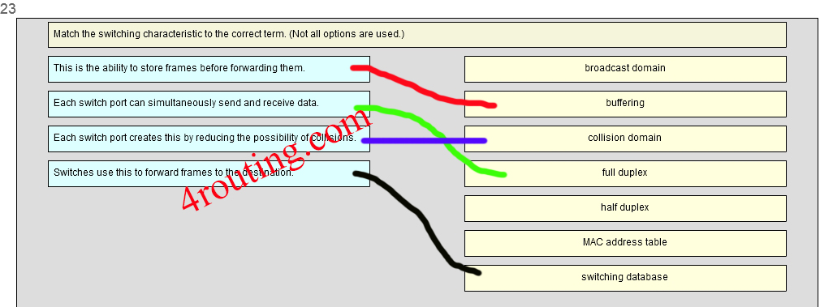

26.  
On a switch that is configured with multiple VLANs, which command will remove only VLAN 100 from the switch?

**Switch(config)# no vlan 100**

41. Open the PT Activity. Perform the tasks in the activity instructions and then answer the question.  
What is the problem preventing PC0 and PC1 from communicating with PC2 and PC3?

**The serial interfaces of the routers are in different subnets.**

56. Open the PT Activity. Perform the tasks in the activity instructions and then answer the question.

Which keyword is displayed on the web browser?

**Welldone!**

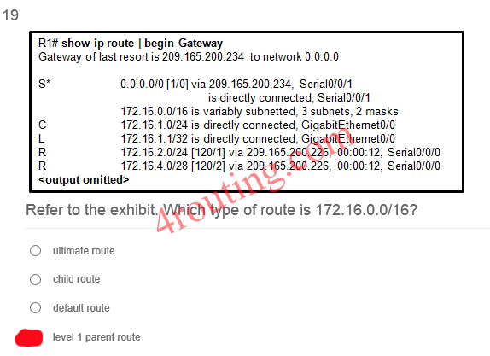

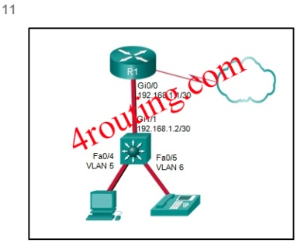11. Refer to the exhibit. A Layer 3 switch routes for three VLANs and connects to a router for Internet connectivity. Which two configurations would be applied to the switch? (Choose two.)

**(config)# interface gigabitethernet 1/1  
(config-if)# no switchport**

**(config)# ip routing**

[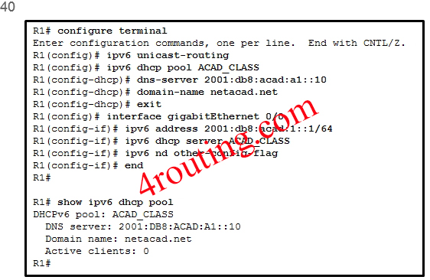](http://4routing.com/wp-content/uploads/2013/12/401.jpg)40. Refer to the exhibit. A network administrator is configuring a router as a DHCPv6 server. The administrator issues a show ipv6 dhcp pool command to verify the configuration. Which statement explains the reason that the number of active clients is 0?

**The state is not maintained by the DHCPv6 server under stateless DHCPv6 operation.**

9. Refer to the exhibit. A network administrator has just configured address translation and is verifying the configuration. What three things can the administrator verify? (Choose three.)  
  
[](http://ccnav5.com/wp-content/uploads/2014/10/i215839v1n1_NAT.png)  
**A standard access list numbered 1 was used as part of the configuration process.**  
**Address translation is working.**  
**Two types of NAT are enabled.**

32. Refer to the exhibit. How did the router obtain the last route that is shown?  
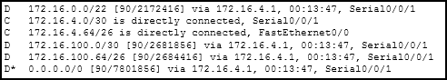  
**Another router in the same organization provided the default route by using a dynamic routing protocol.**

53. Refer to the exhibit. How many broadcast and collision domains exist in the topology?

[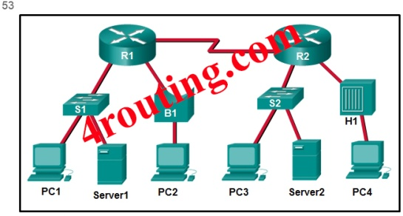](http://4routing.com/wp-content/uploads/2013/12/531.jpg)

**5 broadcast domains and 10 collision domains**

58. Refer to the exhibit. If RIPng is enabled, how many hops away does R1 consider the 2001:0DB8:ACAD:1::/64 network to be?

[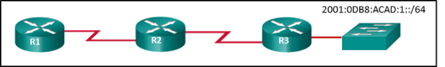](http://4routing.com/wp-content/uploads/2013/12/i215852v1n1_215852v3.png)

**3**

[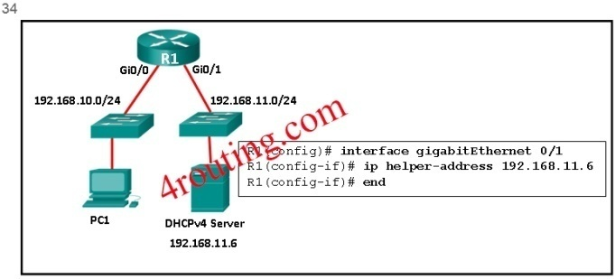](http://4routing.com/wp-content/uploads/2013/12/341.jpg)34. Refer to the exhibit. R1 has been configured as shown. However, PC1 is not able to receive an IPv4 address. What is the problem?

R1 is not configured as a DHCPv4 server.  
A DHCP server must be installed on the same LAN as the host that is receiving the IP address.  
The ip address dhcp command was not issued on the interface Gi0/1.  
**The ip helper-address command was applied on the wrong interface.**

[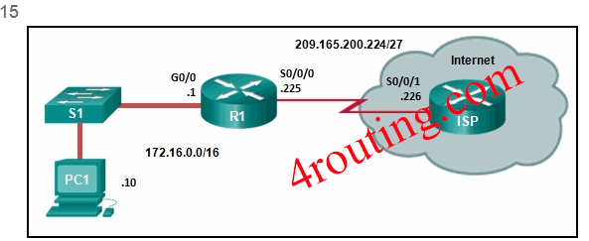](http://4routing.com/wp-content/uploads/2013/12/151.jpg)15.__ Refer to the exhibit. R1 was configured with the static route command ip route 209.165.200.224 255.255.255.224 S0/0/0 and consequently users on network 172.16.0.0/16 are unable to reach resources on the Internet. How should this static route be changed to allow user traffic from the LAN to reach the Internet?  
  
  
**Change the destination network and mask to 0.0.0.0 0.0.0.0.0.**

[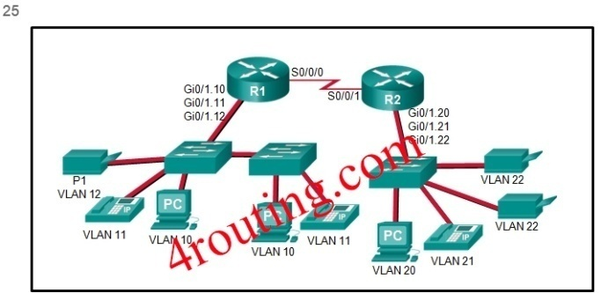](http://4routing.com/wp-content/uploads/2013/12/251.jpg)25. Refer to the exhibit. The Gigabit interfaces on both routers have been configured with subinterface numbers that match the VLAN numbers connected to them. PCs on VLAN 10 should be able to print to the P1 printer on VLAN 12. PCs on VLAN 20 should print to the printers on VLAN 22. What interface and in what direction should you place a standard ACL that allows printing to P1 from data VLAN 10, but stops the PCs on VLAN 20 from using the P1 printer? (Choose two.)

**outbound**  
**R1 Gi0/1.12**

[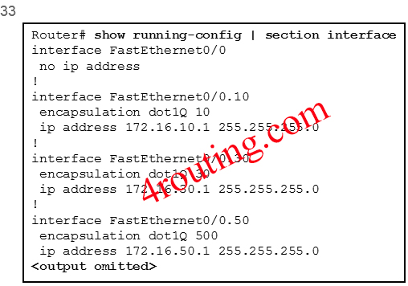](http://4routing.com/wp-content/uploads/2013/12/331.jpg)

33. Refer to the exhibit. The partial configuration that is shown was used to configure router on a stick for VLANS 10, 30, and 50. However, testing shows that there are some connectivity problems between the VLANs. Which configuration error is causing this problem?

**The wrong VLAN has been configured on subinterface Fa0/0.50.**

[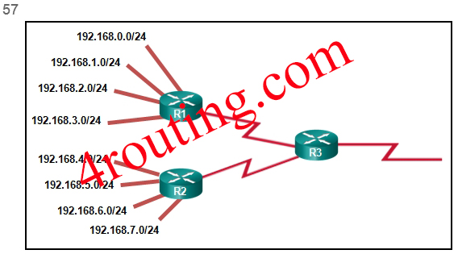](http://4routing.com/wp-content/uploads/2013/12/571.jpg)

57. Refer to the exhibit.

What summary static address would be configured on R1 to advertise to R3?  
**192.168.0.0/22**

34. Refer to the exhibit. Which type of IPv6 static route is configured in the exhibit?  
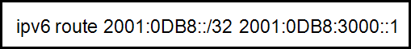  
**recursive static route**

33. Refer to the exhibit. Which type of route is 172.16.0.0/16?  
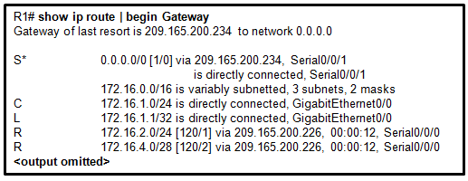  
**level 1 parent route**

22 **TFTP** is a best-effort, connectionless application layer protocol that is used to transfer files.

5. The computers used by the network administrators for a school are on the 10.7.0.0/27 network. Which two commands are needed at a minimum to apply an ACL that will ensure that only devices that are used by the network administrators will be allowed Telnet access to the routers? (Choose two.)  
**ip access-group 5 in  
access-list 5 permit 10.7.0.0 0.0.0.31**

25. The question is from where is the system image being loaded. Answer: **flash**.



17. Two employees in the Sales department work different shifts with their laptop computers and share the same Ethernet port in the office. Which set of commands would allow only these two laptops to use the Ethernet port and create violation log entry without shutting down the port if a violation occurs?

**switchport mode access  
switchport port-security  
switchport port-security maximum 2  
switchport port-security mac-address sticky  
switchport port-security violation restrict**

6. What address type will OSPFv3 use to form adjacency to neighboring routers?  
the all-link router multicast  
the all OSPF router multicast  
the global unicast of the interface  
the link-local address of the interface

27. What are three characteristics of multicast transmission? (Choose three.)

**A single packet can be sent to a group of hosts.  
Multicast messages map lower layer addresses to upper layer addresses.  
Multicast transmission can be used by routers to exchange routing information.**  
1.What are two features of a link-state routing protocol? (Choose two.)  
**Routers send triggered updates in response to a change.  
Routers create a topology of the network by using information from other routers.**

38. What are two ways of turning off DTP on a trunk link between switches? (Choose two.)

**Configure attached switch ports with the nonegotiate command option.**  
**Place the two attached switch ports in access mode.**

48.What benefit does NAT64 provide?

**It allows sites to connect IPv6 hosts to an IPv4 network by translating the IPv6 addresses to IPv4 addresses.**

35.What best describes the operation of distance vector routing protocols?

**They send their routing tables to directly connected neighbors.**

20.What caused the following error message to appear?

01:11:12: %PM-4-ERR_DISABLE: psecure-violation error detected on Fa0/8, putting Fa0/8 in err-disable state  
01:11:12: %PORT_SECURITY-2-PSECURE_VIOLATION: Security violation occurred, caused by MAC address 0011.a0d4.12a0 on port FastEthernet0/8.  
01:11:13: %LINEPROTO-5-UPDOWN: Line protocol on Interface FastEthernet0/8, changed state to down  
01:11:14: %LINK-3-UPDOWN: Interface FastEthernet0/8, changed state to down

**Port security was enabled on the switch port, and an unauthorized connection was made on switch port Fa0/8.**

24.What does the cost of an OSPF link indicate?  
**A lower cost indicates a better path to the destination than a higher cost does.**

47. What happens immediately after two OSPF routers have exchanged hello packets and have formed a neighbor adjacency?

**They exchange abbreviated lists of their LSDBs**

32. What is a disadvantage of NAT?

**There is no end-to-end addressing.**

28.What is a function of the distribution layer?

**interconnection of large-scale networks in wiring closets**

12. What is the protocol that is used to discover a physical address from a known logical address and what message type does it use?  
**ARP, broadcast**

40. What is the purpose of an access list that is created as part of configuring IP address translation?

**The access list defines the private IP addresses that are to be translated.**

49. What is the purpose of setting the native VLAN separate from data VLANs?

**A separate VLAN should be used to carry uncommon untagged frames to avoid bandwidth contention on data VLANs.**

19 What three application layer protocols are part of the TCP/IP protocol suite? (Choose three.)  
**FTP**  
**DHCP**  
**DNS**

6. When a Cisco switch receives untagged frames on a 802.1Q trunk port, which VLAN ID is the traffic switched to by default?

**native VLAN ID**

38. When configuring a switch to use SSH for virtual terminal connections, what is the purpose of the crypto key generate rsa command?

**create a public and private key pair**

20 Which communication tool allows real-time collaboration?  
**instant messaging**

50. Which command, when issued in the interface configuration mode of a router, enables the interface to acquire an IPv4 address automatically from an ISP, when that link to the ISP is enabled?

**ip address dhcp**

[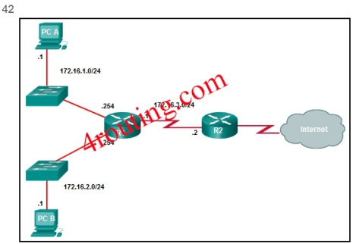](http://4routing.com/wp-content/uploads/2013/12/421.jpg)**42.** Which command will create a static route on R2 in order to reach PC B?

**R1(config)# ip route 172.16.2.0 255.255.255.0 172.16.3.1**

2. Which command will enable auto-MDIX on a device?  
**S1(config-if)# mdix auto**

17. Which firewall technique blocks incoming packets unless they are responses to internal requests?  
**stateful packet inspection**

29 Which frame forwarding method receives the entire frame and performs a CRC check to detect errors before forwarding the frame?  
**store-and-forward switching**

39.Which information does a switch use to populate the MAC address table?

**the source MAC address and the incoming port**

46.Which kind of message is sent by a DHCP client when its IP address lease has expired?

**a DHCPREQUEST unicast message**

21 Which of the following are primary functions of a router? (Choose two.)  
**packet switching**  
**path selection**

31. Which one of source IPv4 addresses is translated by R1 with PAT?

The computers used by the network administrators for a school are on the 10.7.0.0/27 network. Which two commands are needed at a minimum to apply an ACL that will ensure that only devices that are used by the network administrators will be allowed Telnet access to the routers? (Choose two.)

**access-class 5 in**  
**access-list 5 permit 10.7.0.0 0.0.0.31**

43. Which problem is evident if the show ip interface command shows that the interface is down and the line protocol is down?

**A cable has not been attached to the port.**

8. Which statement describes a route that has been learned dynamically?

**It is automatically updated and maintained by routing protocols.**

51. Which statement is correct about IPv6 routing?

**IPv6 uses the link-local address of neighbors as the next-hop address for dynamic routes.**

35. Which statement is true about the difference between OSPFv2 and OSPFv3?

**OSPFv3 routers do not need to have matching subnets to form neighbor adjacencies.**

4.Which summary IPv6 static route statement can be configured to summarize only the routes to networks 2001:db8:cafe::/58 through 2001:db8:cafe:c0::/58?

**ipv6 route 2001:db8:cafe::/56 S0/0/0**

3.Which switching method drops frames that fail the FCS check?

**store-and-forwardswitching**

37. Which three advantages are provided by static routing? (Choose three.)

**The path a static route uses to send data is known.**  
**Static routing does not advertise over the network, thus providing better security.**  
**Static routing typically uses less network bandwidth and fewer CPU operations than dynamic routing does.**

37. Which three pairs of trunking modes will establish a functional trunk link between two Cisco switches? (Choose three.)

**dynamic desirable – dynamic desirable**  
**dynamic desirable – dynamic auto  
dynamic desirable – trunk**

3. Which three parameters could be in an extended access control list? (Choose three.)  
**destination address and wildcard mask**  
**source address and wildcard mask**  
**access list number between 100 and 199**

31. Which three pieces of information does a link-state routing protocol use initially as link-state information for locally connected links? (Choose three.)

**the cost of that link**  
**the type of network link**  
**the link router interface IP address and subnet mask**

30. Which three requirements are necessary for two OSPFv2 routers to form an adjacency? (Choose three.)

**The link interface subnet masks must match.**  
**The two routers must include the inter-router link network in an OSPFv2 network command.**  
**The OSPF hello or dead timers on each router must match.**

44. Which three values or sets of values are included when creating an extended access control list entry? (Choose three.)

**access list number between 100 and 199**  
**source address and wildcard mask**  
**destination address and wildcard mask**

54. Which two commands can be used to verify the content and placement of access control lists? (Choose two.)

**show access-lists**  
**show running-config**

1. Which two commands should be implemented to return a Cisco 3560 trunk port to its default configuration? (Choose two.)  
**S1(config-if)# no switchport trunk native vlan**  
**S1(config-if)# no switchport trunk allowed vlan**

18.  
Which two factors are important when deciding which interior gateway routing protocol to use? (Choose two.)

**speed of convergence**

**scalability**

39. Which two characteristics describe the native VLAN? (Choose two.)

**The native VLAN traffic will be untagged across the trunk link.**  
**The native VLAN provides a common identifier to both ends of a trunk.**

11. Which two methods can be used to provide secure management access to a Cisco switch? (Choose two.)  
**Configure SSH for remote management.  
Configure specific ports for management traffic on a specific VLAN.**

14. Which two packet filters could a network administrator use on an IPv4 extended ACL? (Choose two.)  
**ICMP message type  
destination UDP port number**

16. Which two protocols function at the internet layer? (Choose two.)  
**ICMP**  
**IP**

8. Which two statements are true about half-duplex and full-duplex communications? (Choose two.)  
**Full duplex offers 100 percent potential use of the bandwidth.  
Full duplex allows both ends to transmit and receive simultaneously.**

15. Which two statements describe the characteristics of fiber-optic cabling? (Choose two.)  
**Fiber-optic cabling does not conduct electricity.**  
**Fiber-optic cabling is primarily used as backbone cabling.**

21. Which two statements are characteristics of routed ports on a multilayer switch? (Choose two.)

**They are used for point-to-multipoint links.  
They are not associated with a particular VLAN.**

55. Which type of traffic would most likely have problems when passing through a NAT device?

**IPsec**

36. While analyzing log files, a network administrator notices reoccurring native VLAN mismatches. What is the effect of these reoccurring errors?

**The control and management traffic on the error-occurring trunk port is being misdirected or dropped.**

7. Why would an administrator use a network security auditing tool to flood the switch MAC address table with fictitious MAC addresses?  
**to determine which ports are not correctly configured to prevent MAC address flooding**

**Which value represents the “trustworthiness” of a route and is used to determine which route to install into the routing table when there are multiple routes toward the same destination?**

**administrative distance\***

**Refer to the exhibit. If the switch reboots and all routers have to re-establish OSPF adjacencies, which routers will become the new DR and BDR?**

**Router R4 will become the DR and router R3 will become the BDR.\***

What is the minimum configuration for a router interface that is participating in IPv6 routing?

**to have only a link-local IPv6 address**

Refer to the exhibit. How did the router obtain the last route that is shown?

**Another router in the same organization provided the default route by using a dynamic routing protocol.**

A network administrator is designing an ACL. The networks 192.168.1.0/25, 192.168.0.0/25, 192.168.0.128/25, 192.168.1.128/26, and 192.168.1.192/26 are affected by the ACL. Which wildcard mask, if any, is the most efficient to use when specifying all of these networks in a single ACL permit entry?

**0.0.1.255**

Why would an administrator use a network security auditing tool to flood the switch MAC address table with fictitious MAC addresses?

**to determine which ports are not correctly configured to prevent MAC address flooding**

Refer to the exhibit. A Layer 3 switch routes for three VLANs and connects to a router for Internet connectivity. Which two configurations would be applied to the switch? (Choose two.)

**1. (config)# interface gigabitethernet 1/1   
(config-if)# no switchport   
(config-if)# ip address 192.168.1.2 255.255.255.252**  
**2. (config)# ip routing**

Which two statements are true about half-duplex and full-duplex communications? (Choose two.)

**1. Full duplex offers 100 percent potential use of the bandwidth.  
  
2. Full duplex allows both ends to transmit and receive simultaneously.**

A network administrator is explaining to a junior colleague the use of the lt and gt keywords when filtering packets using an extended ACL. Where would the lt or gt keywords be used?

**in an IPv4 extended ACL that allows packets from a range of TCP ports destined for a specific network device**

Fill in the blank.  
In IPv6, all routes are level ultimate routes.

**1**

A network administrator is using the router-on-a-stick method to configure inter-VLAN routing. Switch port Gi1/1 is used to connect to the router. Which command should be entered to prepare this port for the task?

**Switch(config)# interface gigabitethernet 1/1   
Switch(config-if)# switchport mode trunk**

### **Refer to the exhibit. R1 was configured with the static route command ip route 209.165.200.224 255.255.255.224 S0/0/0 and consequently users on network 172.16.0.0/16 are unable to reach resources on the Internet. How should this static route be changed to allow user traffic from the LAN to reach the Internet?**

Change the destination network and mask to 0.0.0.0 0.0.0.0.0.

### **Refer to the exhibit. Which type of route is 172.16.0.0/16?**

level 1 parent route

### **A network contains multiple VLANs spanning multiple switches. What happens when a device in VLAN 20 sends a broadcast Ethernet frame?**

Only devices in VLAN 20 see the frame.

### **Fill in the blank. The acronym describes the type of traffic that has strict QoS requirements and utilizes a one-way overall delay less than 150 ms across the network.**

VoIP

### **Match the switching characteristic to the correct term. (Not all options are used.) A. This is the ability to store frames before forwarding them. B. Each switch port can simultaneously send and receive data. C. Each switch port creates this by reducing the possibility of collisions D. Switches use this to forward frames to the destination**

1. broadcast domain  
  
2. buffering - A  
  
3. collision domain - C  
  
4. full duplex - B  
  
5. half duplex  
  
6. MAC address table  
  
7. switching database - D

### **What benefit does NAT64 provide?**

It allows sites to connect IPv6 hosts to an IPv4 network by translating the IPv6 addresses to IPv4 addresses.

### **What is a disadvantage of NAT?**

There is no end-to-end addressing.

### **Refer to the exhibit. The Gigabit interfaces on both routers have been configured with subinterface numbers that match the VLAN numbers connected to them. PCs on VLAN 10 should be able to print to the P1 printer on VLAN 12. PCs on VLAN 20 should print to the printers on VLAN 22. What interface and in what direction should you place a standard ACL that allows printing to P1 from data VLAN 10, but stops the PCs on VLAN 20 from using the P1 printer? (Choose two.)**

1. outbound  
2. R1 Gi0/1.12

### **Two employees in the Sales department work different shifts with their laptop computers and share the same Ethernet port in the office. Which set of commands would allow only these two laptops to use the Ethernet port and create violation log entry without shutting down the port if a violation occurs?**

switchport mode access  
switchport port-security  
switchport port-security maximum 2  
switchport port-security mac-address sticky  
switchport port-security violation restrict

### **Which command will create a static route on R2 in order to reach PC B?**

R1(config)# ip route 172.16.2.0 255.255.255.0 172.16.3.1

### **Refer to the exhibit. The partial configuration that is shown was used to configure router on a stick for VLANS 10, 30, and 50. However, testing shows that there are some connectivity problems between the VLANs. Which configuration error is causing this problem?**

The wrong VLAN has been configured on subinterface Fa0/0.50.

### **Which three pieces of information does a link-state routing protocol use initially as link-state information for locally connected links? (Choose three.)**

1. the cost of that link   
  
2. the type of network link   
  
3. the link router interface IP address and subnet mask

### **Which switching method drops frames that fail the FCS check?**

store-and-forward switching

### **Which two commands should be implemented to return a Cisco 3560 trunk port to its default configuration? (Choose two.)**

1. S1(config-if)# no switchport trunk native vlan  
  
2. S1(config-if)# no switchport trunk allowed vlan

### **Which command will enable auto-MDIX on a device?**

S1(config-if)# mdix auto

### **What is the effect of issuing the passive-interface default command on a router that is configured for OSPF?**

It prevents OSPF messages from being sent out any OSPF-enabled interface.

### **Which two packet filters could a network administrator use on an IPv4 extended ACL? (Choose two.)**

1. ICMP message type  
  
2. destination UDP port number

### **What is the purpose of setting the native VLAN separate from data VLANs?**

A separate VLAN should be used to carry uncommon untagged frames to avoid bandwidth contention on data VLANs.

### **Which three advantages are provided by static routing? (Choose three.)**

1. The path a static route uses to send data is known.  
  
2. Static routing does not advertise over the network, thus providing better security.   
  
3. Static routing typically uses less network bandwidth and fewer CPU operations than dynamic routing does.

### **A network administrator is implementing a distance vector routing protocol between neighbors on the network. In the context of distance vector protocols, what is a neighbor?**

routers that share a link and use the same routing protocol

### **Refer to the exhibit. How many broadcast and collision domains exist in the topology?**

5 broadcast domains and 10 collision domains

### **Which command, when issued in the interface configuration mode of a router, enables the interface to acquire an IPv4 address automatically from an ISP, when that link to the ISP is enabled?**

ip address dhcp

### **A college marketing department has a networked storage device that uses the IP address 10.18.7.5, TCP port 443 for encryption, and UDP port 4365 for video streaming. The college already uses PAT on the router that connects to the Internet. The router interface has the public IP address of 209.165.200.225/30. The IP NAT pool currently uses the IP addresses ranging from 209.165.200.228-236. Which configuration would the network administrator add to allow this device to be accessed by the marketing personnel from home?**

ip nat inside source static tcp 10.18.7.5 443 209.165.200.225 443  
ip nat inside source static udp 10.18.7.5 4365 209.165.200.225 4365

### **How is the router ID for an OSPFv3 router determined?**

the highest IPv4 address on an active interface

### **Which two factors are important when deciding which interior gateway routing protocol to use? (Choose two.)**

1. speed of convergence  
  
2. scalability

### **A network administrator is adding ACLs to a new IPv6 multirouter environment. Which IPv6 ACE is automatically added implicitly at the end of an ACL so that two adjacent routers can discover each other?**

permit icmp any any nd-na

### **Refer to the exhibit. A network administrator is configuring a router as a DHCPv6 server. The administrator issues a show ipv6 dhcp pool command to verify the configuration. Which statement explains the reason that the number of active clients is 0?**

The state is not maintained by the DHCPv6 server under stateless DHCPv6 operation.

### **Which statement is correct about IPv6 routing?**

IPv6 uses the link-local address of neighbors as the next-hop address for dynamic routes.

### **A router has used the OSPF protocol to learn a route to the 172.16.32.0/19 network. Which command will implement a backup floating static route to this network?**

ip route 172.16.32.0 255.255.224.0 S0/0/0 200

### **Which three values or sets of values are included when creating an extended access control list entry? (Choose three.)**

1. access list number between 100 and 199   
  
2. source address and wildcard mask   
  
3. destination address and wildcard mask

### **Which two statements are characteristics of routed ports on a multilayer switch? (Choose two.)​**

1. They are used for point-to-multipoint links.  
  
2. They are not associated with a particular VLAN.

### **Refer to the exhibit. If RIPng is enabled, how many hops away does R1 consider the 2001:0DB8:ACAD:1::/64 network to be?**

3

### **A small-sized company has 20 workstations and 2 servers. The company has been assigned a group of IPv4 addresses 209.165.200.224/29 from its ISP. What technology should the company implement in order to allow the workstations to access the services over the Internet?**

dynamic NAT

### **Refer to the exhibit. A network administrator has just configured address translation and is verifying the configuration. What three things can the administrator verify? (Choose three.)**

1. The name of the NAT pool is refCount.  
  
2. A standard access list numbered 1 was used as part of the configuration process.  
  
3. Address translation is working.



### **Refer to the exhibit. R1 has been configured as shown. However, PC1 is not able to receive an IPv4 address. What is the problem?​**

The ip helper-address command was applied on the wrong interface.

### **Which statement is true about the difference between OSPFv2 and OSPFv3?**

OSPFv3 routers do not need to have matching subnets to form neighbor adjacencies.

### **The computers used by the network administrators for a school are on the 10.7.0.0/27 network. Which two commands are needed at a minimum to apply an ACL that will ensure that only devices that are used by the network administrators will be allowed Telnet access to the routers? (Choose two.)**

1. access-list 5 permit 10.7.0.0 0.0.0.31  
  
2. access-class 5 in

### **Fill in the blank. The OSPF Type 1 packet is the ​ packet.**

hello

### **When a Cisco switch receives untagged frames on a 802.1Q trunk port, which VLAN ID is the traffic switched to by default?**

native VLAN ID

### **Match the router memory type that provides the primary storage for the router feature. (Not all options are used.) A. flash B. NVRAM C. RAM D. ROM**

1. console access  
  
2. full operating system - A  
  
3. limited operating system - D  
  
4. routing table - C  
  
5. startup configuration file - B

### **What happens immediately after two OSPF routers have exchanged hello packets and have formed a neighbor adjacency?**

They exchange abbreviated lists of their LSDBs.

### **Which type of traffic would most likely have problems when passing through a NAT device?**

IPsec

### **What does the cost of an OSPF link indicate?**

A lower cost indicates a better path to the destination than a higher cost does.

### **Which information does a switch use to populate the MAC address table?**

the source MAC address and the incoming port

### **Match the order in which the link-state routing process occurs on a router. (Not all options are used.) A. step 1 B. step 2 C. step 3 D. step 4 E. step 5**

1. Each router is responsible for "saying hello" to its neighbors on directly connected networks. - B  
  
2. Each router builds a Link-State Packet (LSP) containing the state of each directly connected link - C  
  
3. Each router learns about its own directly connected networks. - A  
  
4. Each router increments the hop count for the destination network.  
  
5. Each router floods the LSP to all neighbors, who then store all LSPs received in a database - D  
  
6. Each router uses the database to construct a complete map of the topology and computes the best - E

### **Which two methods can be used to provide secure management access to a Cisco switch? (Choose two.)**

1. Configure specific ports for management traffic on a specific VLAN.  
  
2. Configure SSH for remote management.

### **Which kind of message is sent by a DHCP client when its IP address lease has expired?​**

a DHCPREQUEST unicast message​

### **Which three requirements are necessary for two OSPFv2 routers to form an adjacency? (Choose three.)**

1. The link interface subnet masks must match.   
  
2. The two routers must include the inter-router link network in an OSPFv2 network command.   
  
3. The OSPF hello or dead timers on each router must match.

**1 Which command would be best to use on an unused switch port if a company adheres to the best practices as recommended by Cisco?**  
**shutdown\***

**2**

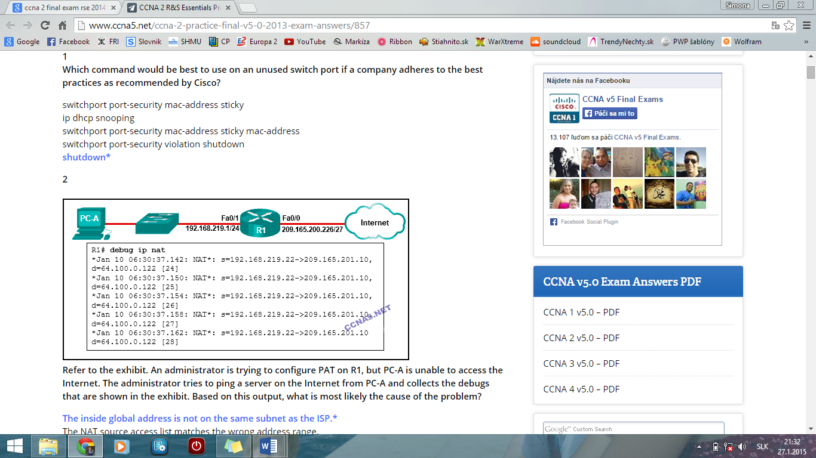  
**Refer to the exhibit. An administrator is trying to configure PAT on R1, but PC-A is unable to access the Internet. The administrator tries to ping a server on the Internet from PC-A and collects the debugs that are shown in the exhibit. Based on this output, what is most likely the cause of the problem?**  
**The inside global address is not on the same subnet as the ISP.\***

**3 A small company has a web server in the office that is accessible from the Internet. The IP address 192.168.10.15 is assigned to the web server. The network administrator is configuring the router so that external clients can access the web server over the Internet. Which item is required in the NAT configuration?**  
**the ip nat inside source command to link the inside local and inside global addresses\***

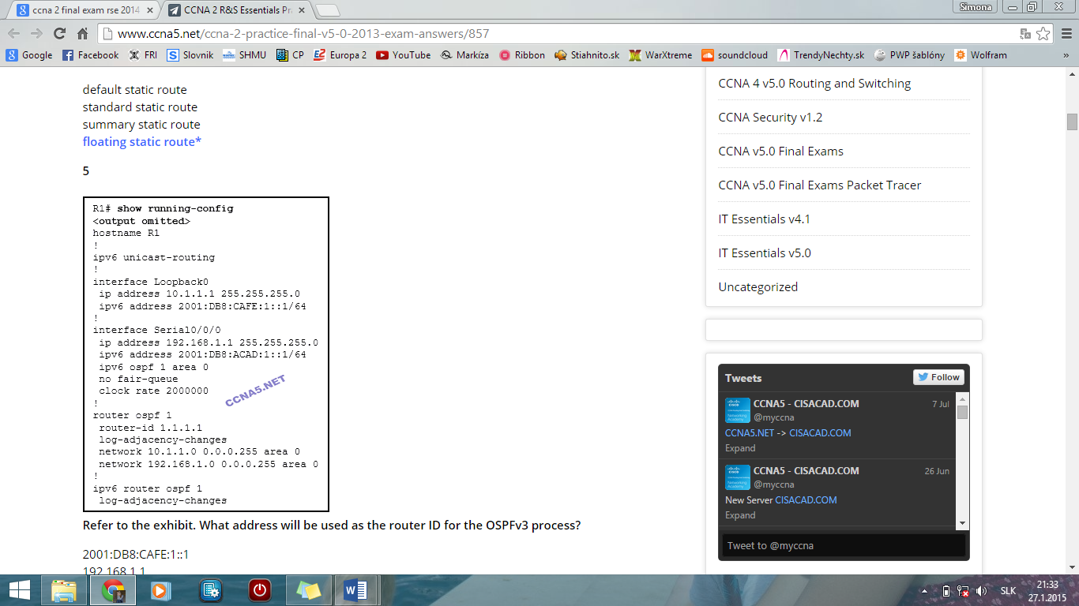**4 Which type of static route typically uses the distance parameter in the ip route global configuration command?**  
**floating static route\***

**5** **Refer to the exhibit. What address will be used as the router ID for the OSPFv3 process?**  
**10.1.1.1\***

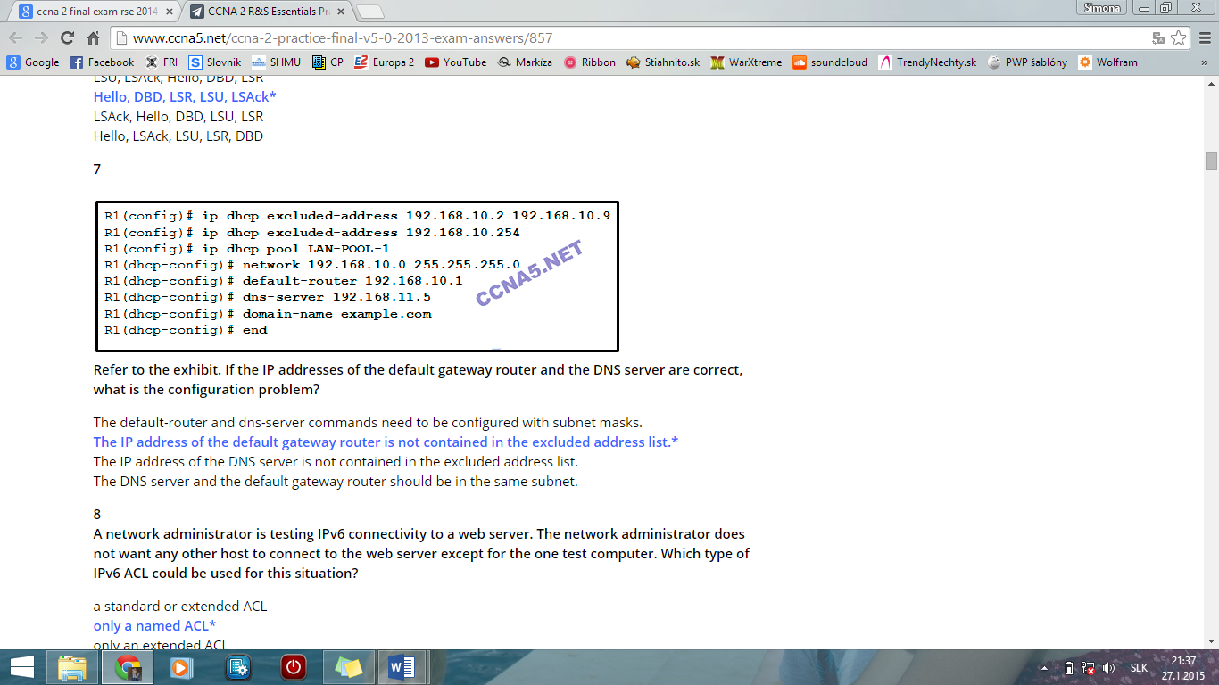  
**6 What is the order of packet types used by an OSPF router to establish convergence?**  
**Hello, DBD, LSR, LSU, LSAck\***

**7** **Refer to the exhibit. If the IP addresses of the default gateway router and the DNS server are correct, what is the configuration problem?**  
**The IP address of the default gateway router is not contained in the excluded address list.\***

**8 A network administrator is testing IPv6 connectivity to a web server. The network administrator does not want any other host to connect to the web server except for the one test computer. Which type of IPv6 ACL could be used for this situation?**  
**only a named ACL\***

**9**

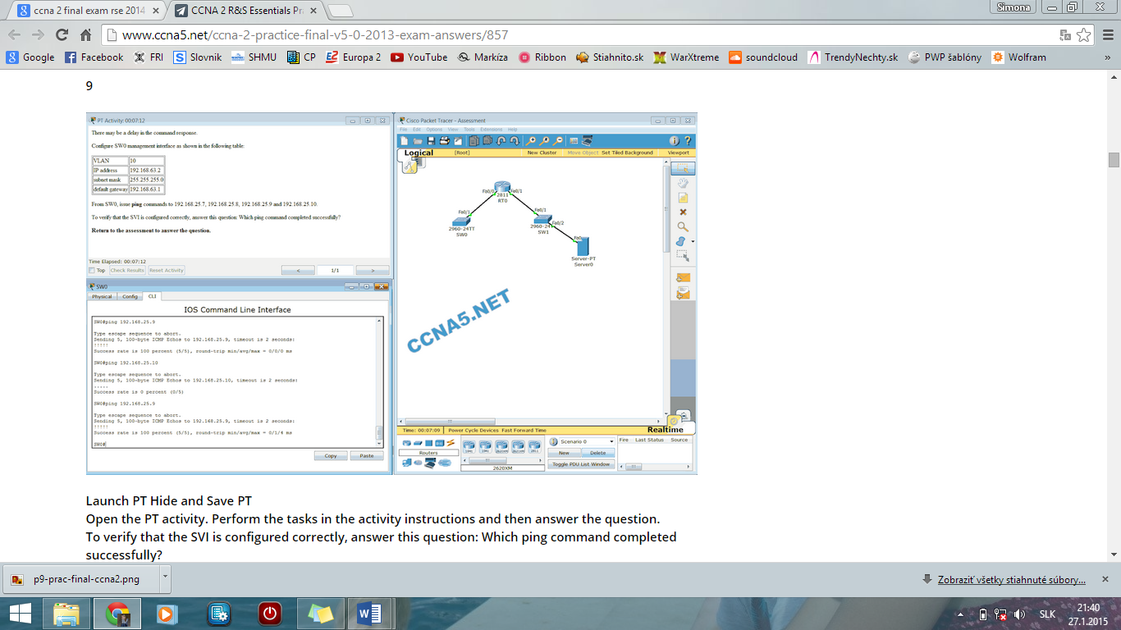

**Launch PT Hide and Save PT**  
**Open the PT activity. Perform the tasks in the activity instructions and then answer the question.**  
**To verify that the SVI is configured correctly, answer this question: Which ping command completed successfully?​**  
**ping 192.168.25.9\***  
**CONFIGURATION**

SW0(config)#**interface vlan 10**  
SW0(config-if)#**ip address 192.168.63.2 255.255.255.0**  
SW0(config-if)#**exit**  
SW0(config)#**ip default-gateway 192.168.63.1**  
SW0(config)#**end**

**10 What is an advantage of using dynamic routing protocols instead of static routing?**  
**ability to actively search for new routes if the current path becomes unavailable​\***

**11 How many classful networks are summarized by the static summary route ip route 192.168.32.0 255.255.248.0 S0/0/0?**  
**8\***

**12 Which switching method provides error-free data transmission?**  
**store-and-forward\***

**13 A client is using SLAAC to obtain an IPv6 address for its interface. After an address has been generated and applied to the interface, what must the client do before it can begin to use this IPv6 address?**  
**It must send an ICMPv6 Neighbor Solicitation message to ensure that the address is not already in use on the network.\***

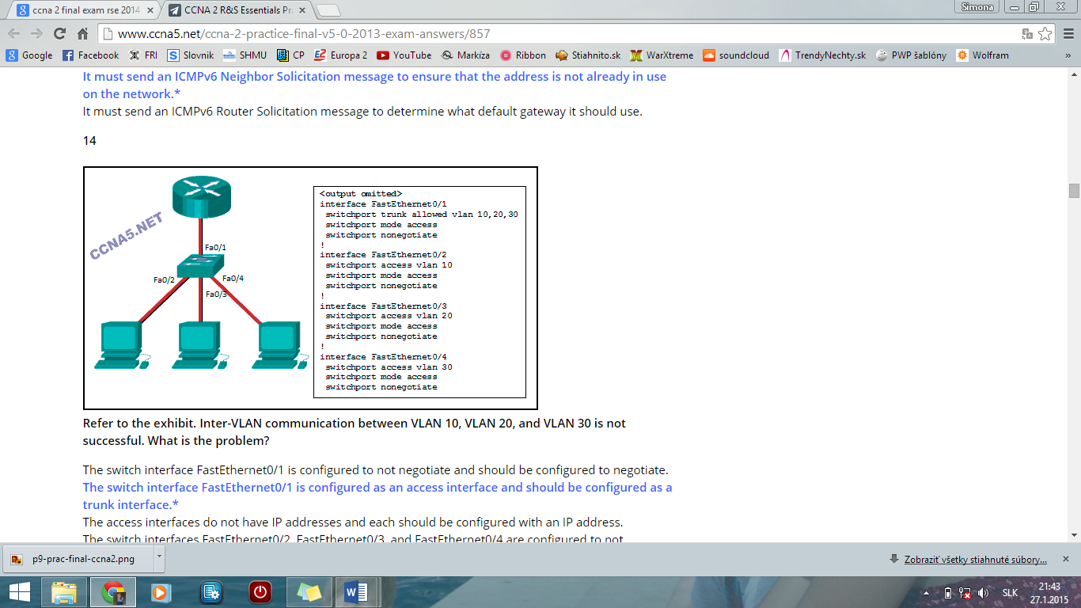**14** **Refer to the exhibit. Inter-VLAN communication between VLAN 10, VLAN 20, and VLAN 30 is not successful. What is the problem?**  
**The switch interface FastEthernet0/1 is configured as an access interface and should be configured as a trunk interface.\***

**15 Which network design may be recommended for a small campus site that consists of a single building with a few users?**  
**a collapsed core network design\***

**16 How is the router ID for an OSPFv3 router determined?**  
**the highest IPv4 address on an active interface\***

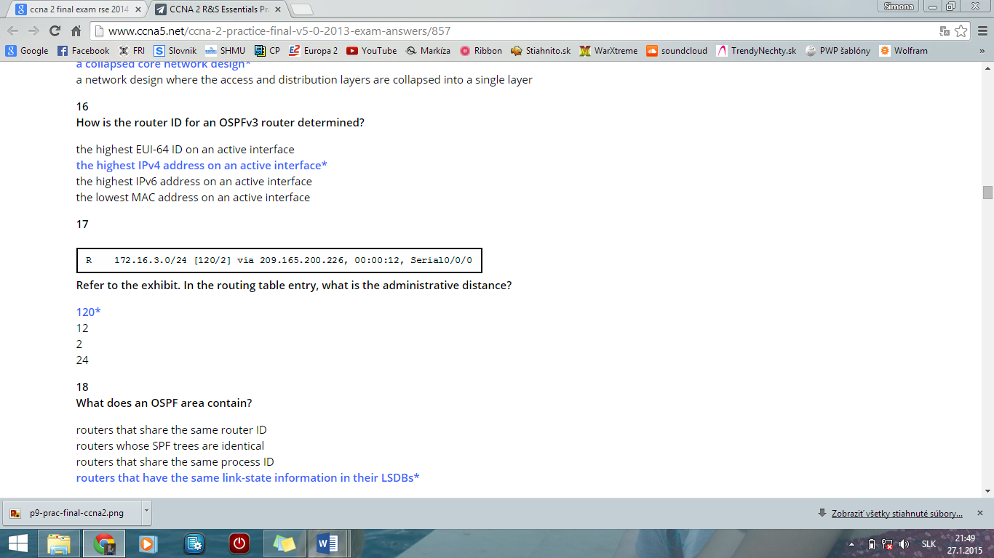**17**  
 **Refer to the exhibit. In the routing table entry, what is the administrative distance?**  
**120\***

**18 What does an OSPF area contain?**  
**routers that have the same link-state information in their LSDBs\***

**19 Which command will create a static default route on R1 to send all traffic to the Internet and use serial 0/0 as the exit interface?**  
**R1(config)# ip route 0.0.0.0 0.0.0.0 serial 0/0\***

**20 What is a result of connecting two or more switches together?**  
**The size of the broadcast domain is increased.\***

**21 Which DHCP IPv4 message contains the following information?**

**Destination address: 255.255.255.255**  
**Client IPv4 address: 0.0.0.0**  
**Default gateway address: 0.0.0.0**  
**Subnet mask: 0.0.0.0**  
**DHCPDISCOVER\***

**22 What is meant by the term “best match” when applied to the routing table lookup process?**  
**longest match\***

**23 Fill in the blank.**  
Using router-on-a-stick inter-VLAN routing, how many subinterfaces have to be configured to support 10 VLANs?​ ” **10**”

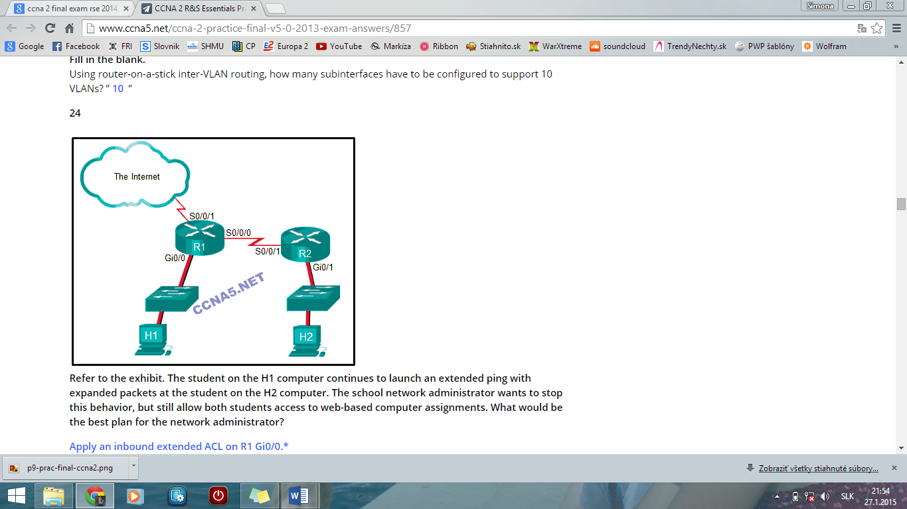**24**

**Refer to the exhibit. The student on the H1 computer continues to launch an extended ping with expanded packets at the student on the H2 computer. The school network administrator wants to stop this behavior, but still allow both students access to web-based computer assignments. What would be the best plan for the network administrator?**  
**Apply an inbound extended ACL on R1 Gi0/0.\***

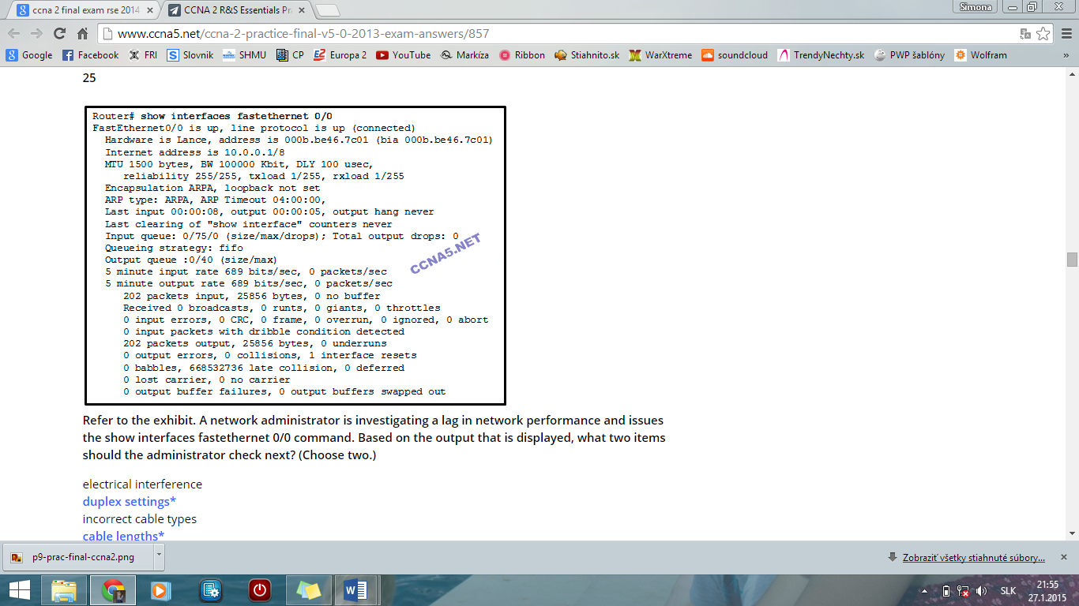**25**  
**Refer to the exhibit. A network administrator is investigating a lag in network performance and issues the show interfaces fastethernet 0/0 command. Based on the output that is displayed, what two items should the administrator check next? (Choose two.)**  
**duplex settings\***  
**cable lengths\***

**26**

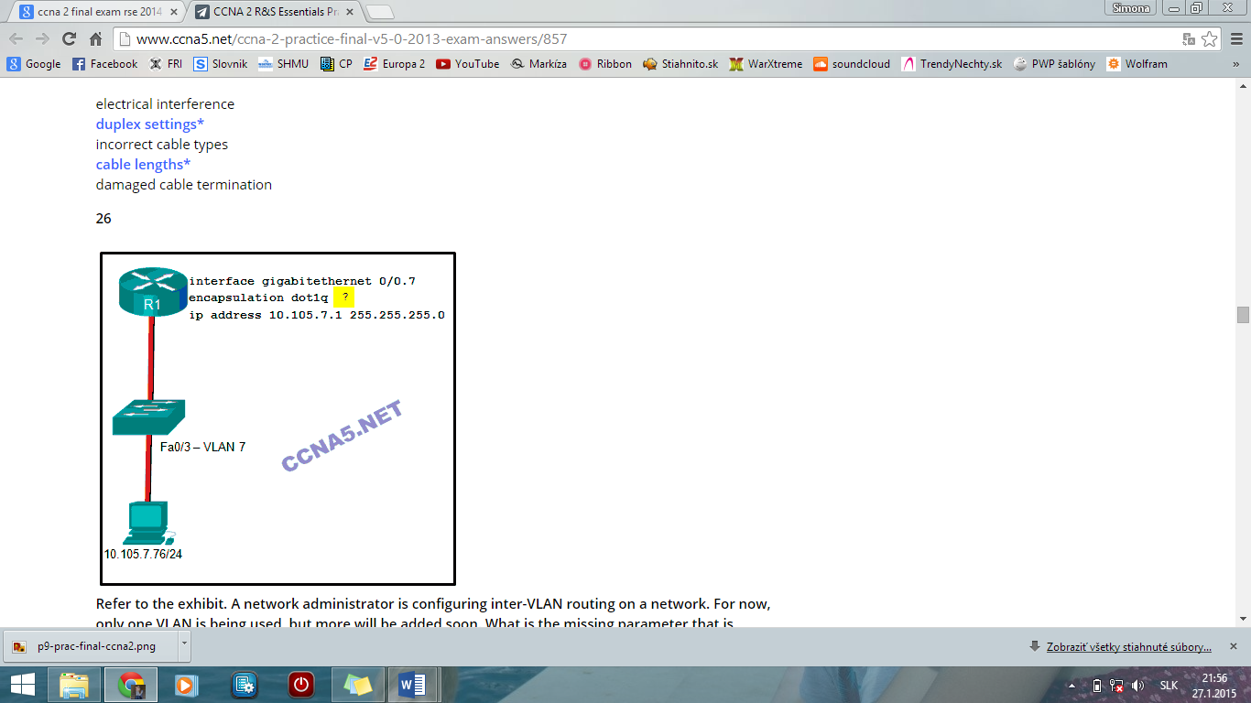  
**Refer to the exhibit. A network administrator is configuring inter-VLAN routing on a network. For now, only one VLAN is being used, but more will be added soon. What is the missing parameter that is shown as the highlighted question mark in the graphic?**  
**It identifies the VLAN number.\***

**27**

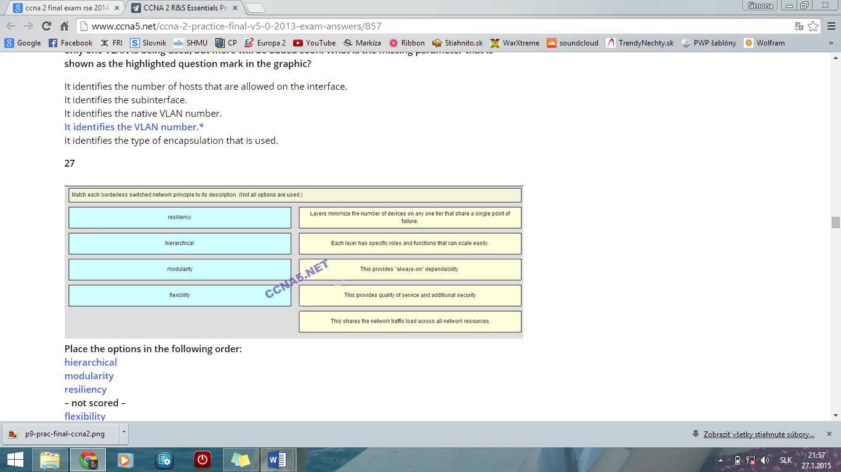  
**Place the options in the following order:**  
**hierarchical**  
**modularity**  
**resiliency**  
**– not scored –**  
**flexibility**

**28 Which command will verify the status of both the physical and the virtual interfaces on a switch?**  
**show ip interface brief\***

**29**

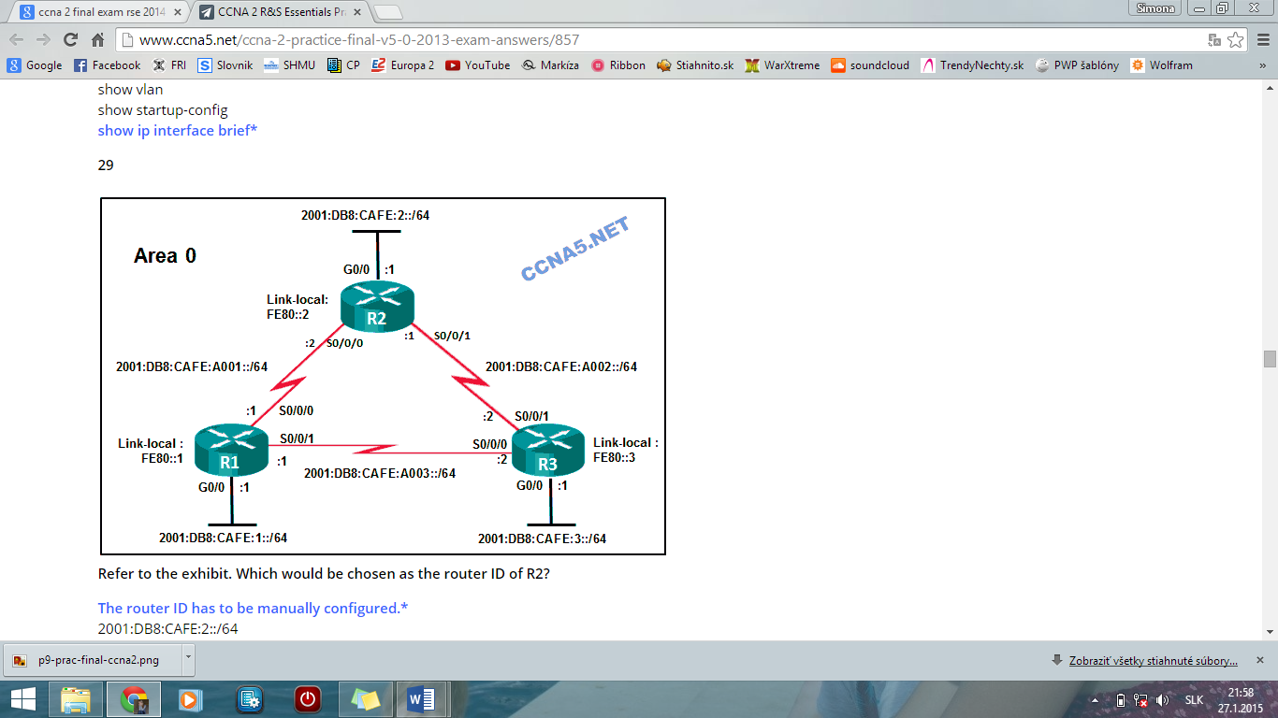  
**Refer to the exhibit. Which would be chosen as the router ID of R2?**  
**The router ID has to be manually configured.\***

**30 A router with two LAN interfaces, two WAN interfaces, and one configured loopback interface is operating with OSPF as its routing protocol. What does the router OSPF process use to assign the router ID?**  
**the loopback interface IP address\***

**31 Which two pieces of information are required when creating a standard access control list? (Choose two.)**  
**source address and wildcard mask\***  
**access list number between 1 and 99\***

**32 What is the effect of the access control list wildcard mask 0.0.0.15? (Choose two.)**  
**The first 28 bits of a supplied IP address will be matched.\***  
**The last four bits of a supplied IP address will be ignored.\***  
  
**33 A college student is studying for the Cisco CCENT certification and is visualizing extended access lists. Which three keywords could immediately follow the keywords permit or deny as part of an extended access list? (Choose three.)**  
**udp\***  
**tcp\***  
**icmp\***

**34 Which two keywords can be used in an access control list to replace a wildcard mask or address and wildcard mask pair? (Choose two.)**  
**any\***  
**host\***

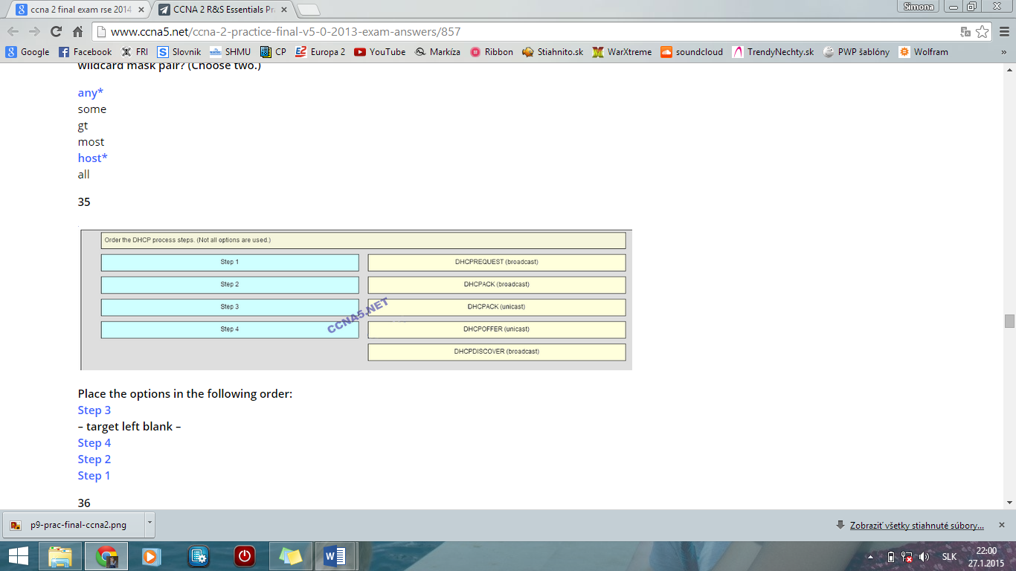**35**

**Place the options in the following order:**  
**Step 3**  
**– target left blank –**  
**Step 4**  
**Step 2**  
**Step 1**

**36 Fill in the blank. Do not use abbreviations.**  
The “**duplex full**” command configures a switch port to operate in the full-duplex mode.

**37**

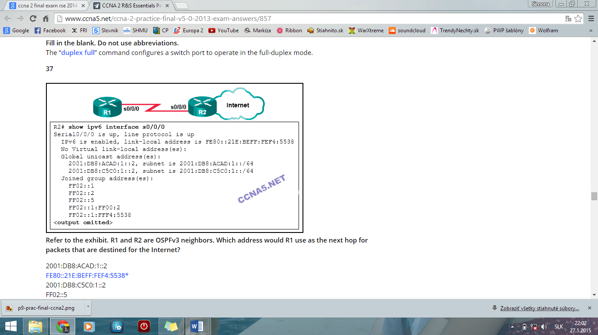  
**Refer to the exhibit. R1 and R2 are OSPFv3 neighbors. Which address would R1 use as the next hop for packets that are destined for the Internet?**  
**FE80::21E:BEFF:FEF4:5538\***

**38 In a routing table which route can never be an ultimate route?**  
**parent route\***

**39**

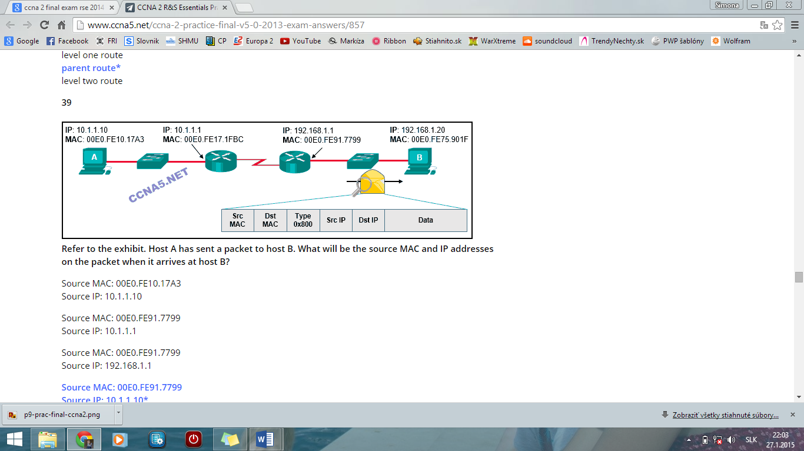  
**Refer to the exhibit. Host A has sent a packet to host B. What will be the source MAC and IP addresses on the packet when it arrives at host B?**  
**Source MAC: 00E0.FE91.7799**  
**Source IP: 10.1.1.10\***

**40 What is the effect of entering the network 192.168.10.1 0.0.0.0 area 0 command in router configuration mode?**  
**OSPF advertisements will include the network on the interface with the IPv4 address 192.168.10.1.\***

**41 An administrator is trying to remove configurations from a switch. After using the command erase startup-config and reloading the switch, the administrator finds that VLANs 10 and 100 still exist on the switch. Why were these VLANs not removed?**  
**Because these VLANs are stored in a file that is called vlan.dat that is located in flash memory, this file must be manually deleted.\***

**42 What is a disadvantage when both sides of a communication use PAT?**  
**End-to-end IPv4 traceability is lost.\***

**43 What is associated with link-state routing protocols?**  
**shortest-path first calculations\***

**44**

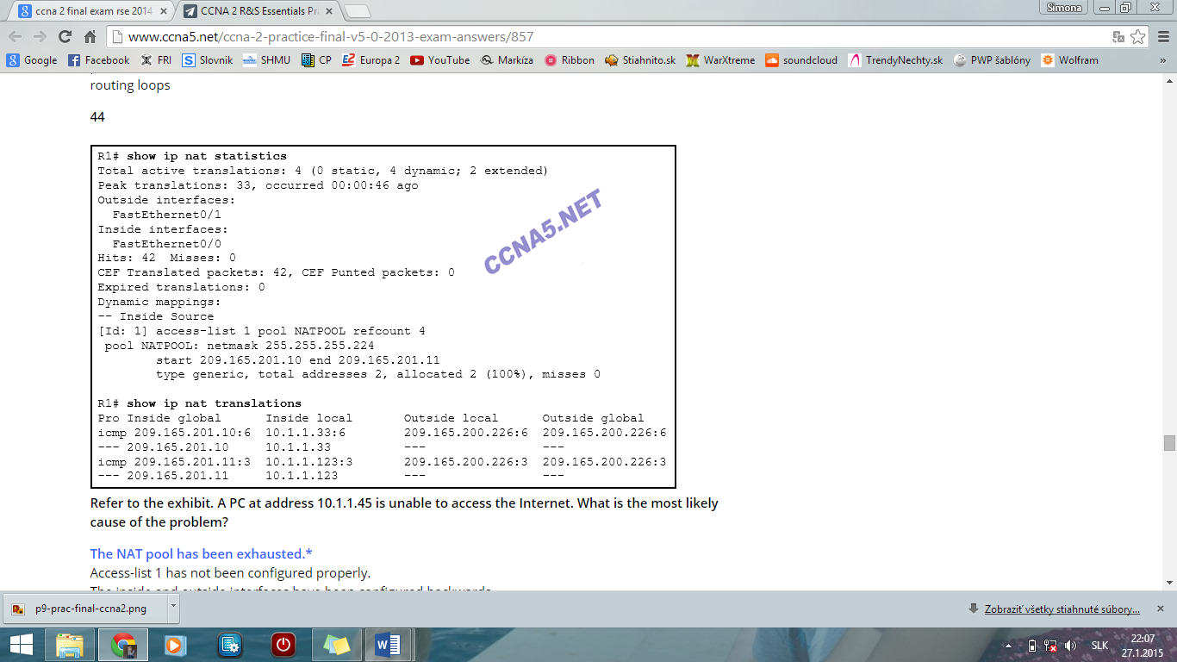  
**Refer to the exhibit. A PC at address 10.1.1.45 is unable to access the Internet. What is the most likely cause of the problem?**  
**The NAT pool has been exhausted.\***  
**45 In which type of attack does a malicious node request all available IP addresses in the address pool of a DHCP server in order to prevent legitimate hosts from obtaining network access?​  
DHCP starvation\***

**46 When does a switch use frame filtering?**  
**The destination MAC address is for a host on the same network segment as the source of the traffic.\***

**47 How will a router handle static routing differently if Cisco Express Forwarding is disabled?**  
**Ethernet multiaccess interfaces will require fully specified static routes to avoid routing inconsistencies.\***

**48 An administrator created and applied an outbound Telnet extended ACL on a router to prevent router-initiated Telnet sessions. What is a consequence of this configuration?**  
**The ACL will not work as desired because an outbound ACL cannot block router-initiated traffic.\***

**49 An administrator attempts to change the router ID on a router that is running OSPFv3 by changing the IPv4 address on the router loopback interface. Once the IPv4 address is changed, the administrator notes that the router ID did not change. What two actions can the administrator take so that the router will use the new IPv4 address as the router ID? (Choose two.)**  
**Reboot the router.\***   
**Clear the IPv6 OSPF process.\***

**50 When routing a large number of VLANs, what are two disadvantages of using the router-on-a-stick inter-VLAN routing method rather than the multilayer switch inter-VLAN routing method? (Choose two.)**  
**A dedicated router is required.\***  
**Multiple subinterfaces may impact the traffic flow speed.\***